# NSABBS0001

| Min. | 1st Qu. | Median | Mean | 3rd Qu. | Max. |
| --- | --- | --- | --- | --- | --- |
| 17 | 42.68182 | 49.27273 | 49.07285 | 56.30303 | 74.5 |

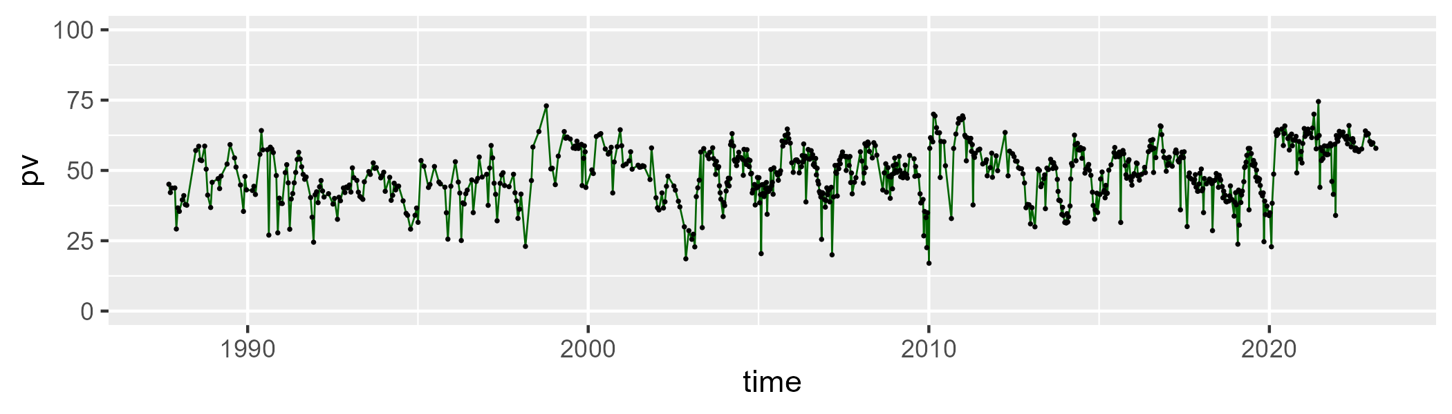

| Min. | 1st Qu. | Median | Mean | 3rd Qu. | Max. |
| --- | --- | --- | --- | --- | --- |
| 7.666667 | 37.02273 | 42.11111 | 41.56229 | 46.45455 | 78.33333 |

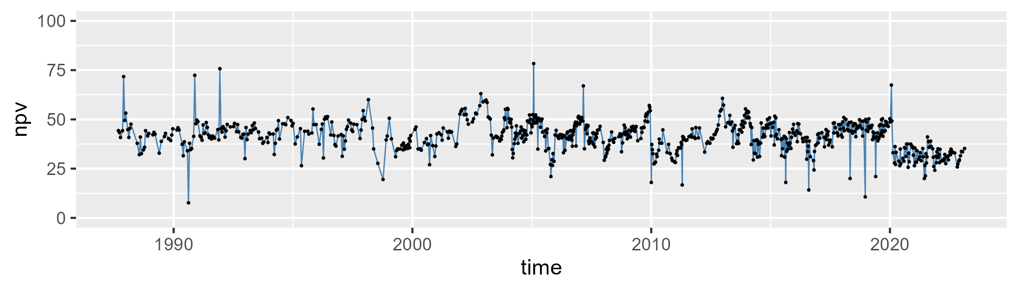

| Min. | 1st Qu. | Median | Mean | 3rd Qu. | Max. |
| --- | --- | --- | --- | --- | --- |
| 0 | 3.727273 | 6.454545 | 8.095399 | 10.27273 | 64.66667 |

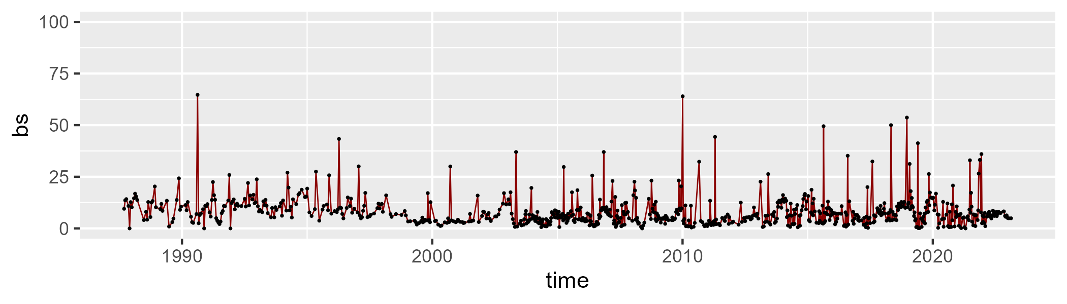

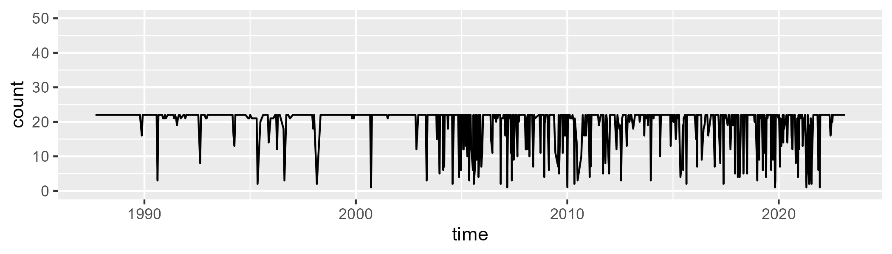

Min. : 1.00 1st Qu.:21.00 Median :22.00 Mean :19.63 3rd Qu.:22.00 Max. :22.00

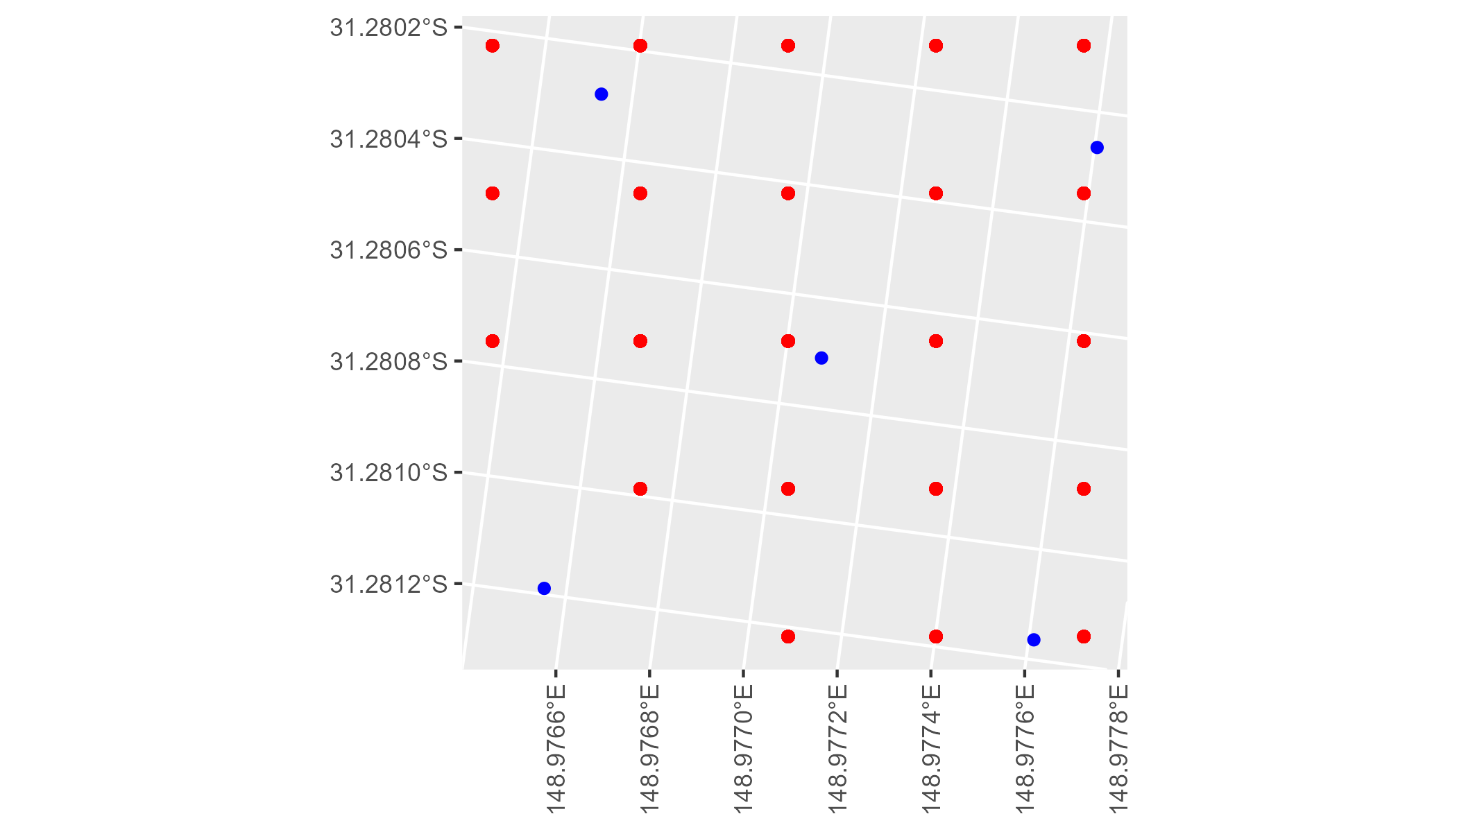

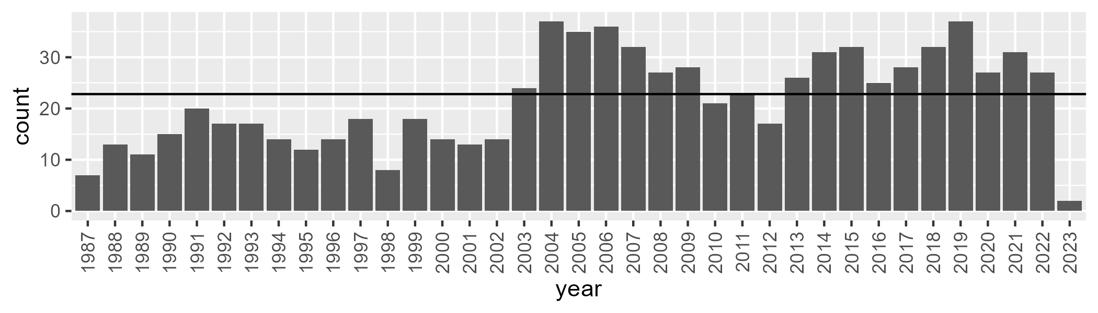

Number of samples: 803

# NSABBS0002

| Min. | 1st Qu. | Median | Mean | 3rd Qu. | Max. |
| --- | --- | --- | --- | --- | --- |
| 17.8125 | 42.42188 | 48.63393 | 47.31185 | 53.75 | 64.27273 |

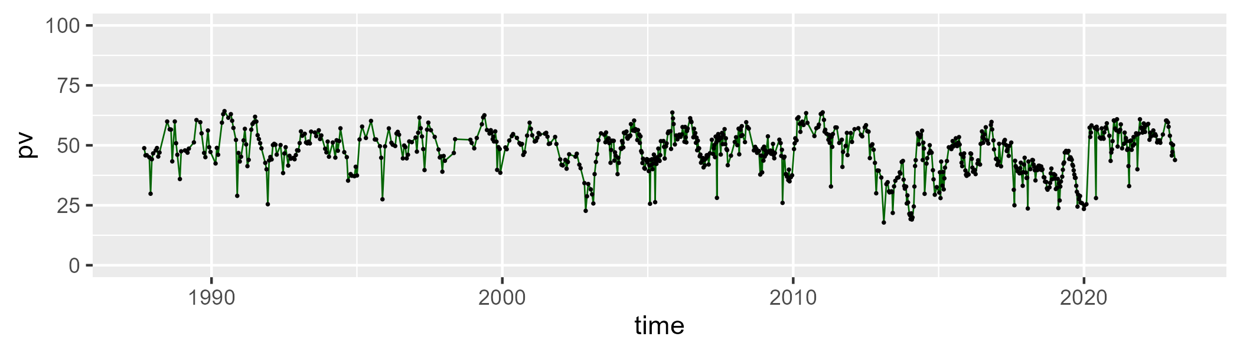

| Min. | 1st Qu. | Median | Mean | 3rd Qu. | Max. |
| --- | --- | --- | --- | --- | --- |
| 4 | 39.83036 | 44 | 44.05379 | 48.625 | 75.1875 |

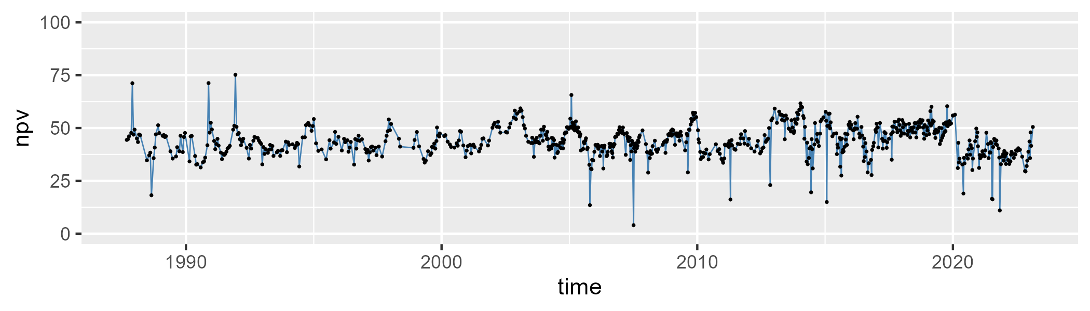

| Min. | 1st Qu. | Median | Mean | 3rd Qu. | Max. |
| --- | --- | --- | --- | --- | --- |
| 0 | 3.5 | 5.75 | 7.416509 | 9 | 56 |

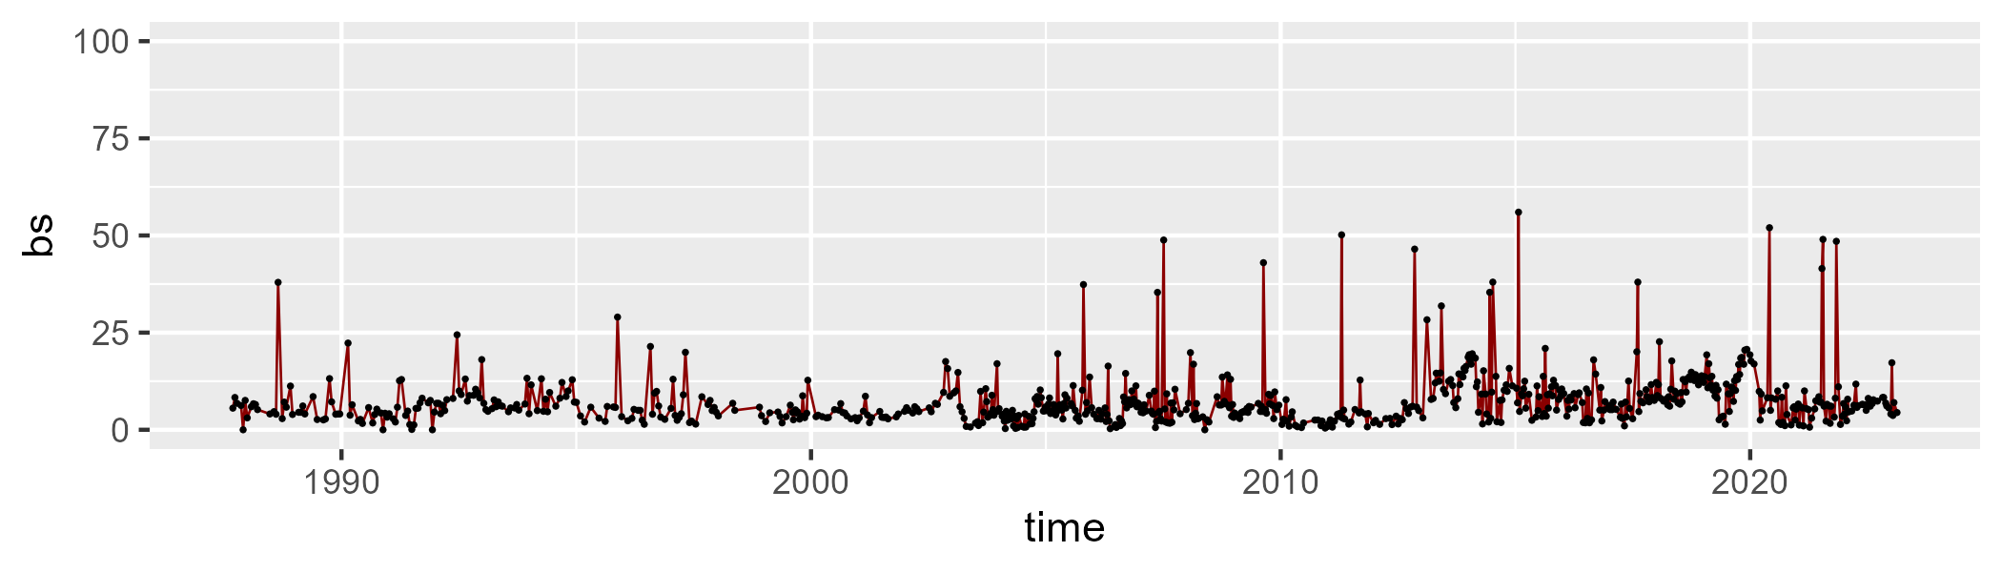

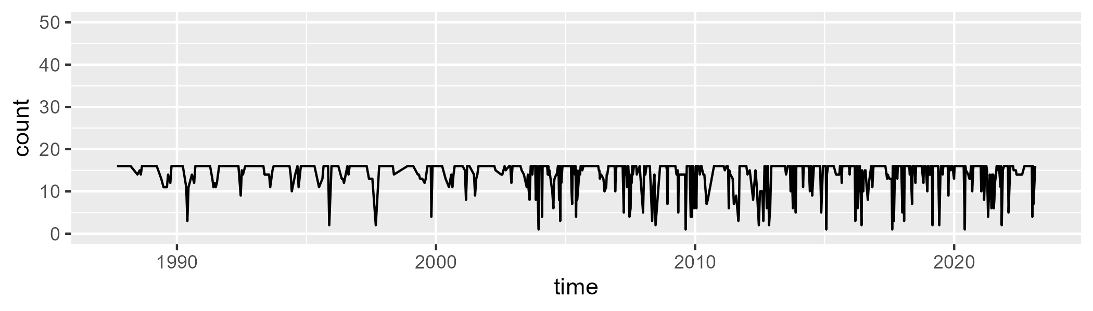

Min. : 1.00 1st Qu.:14.00 Median :16.00 Mean :14.33 3rd Qu.:16.00 Max. :16.00

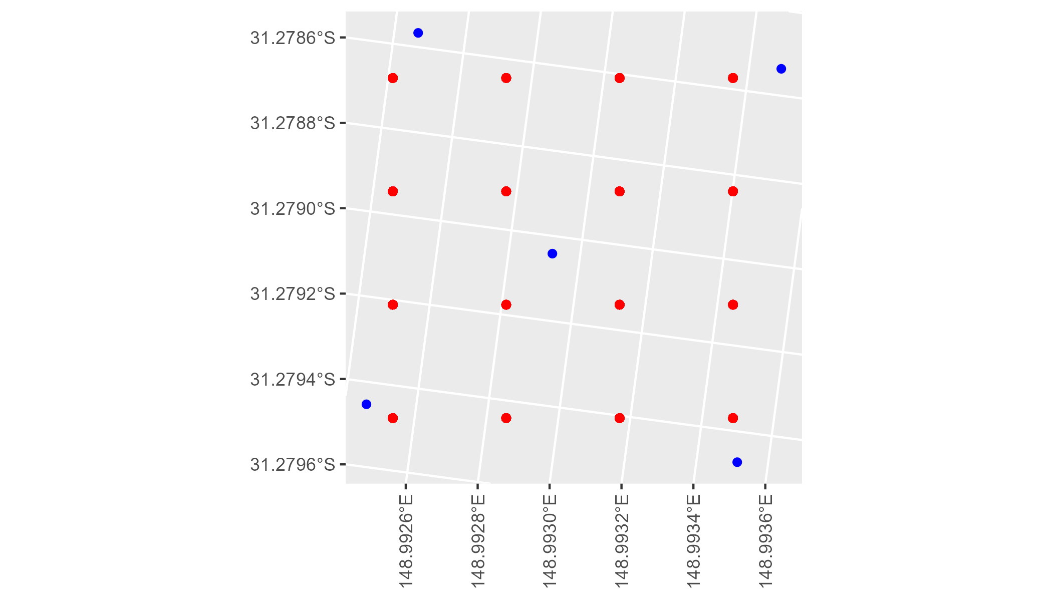

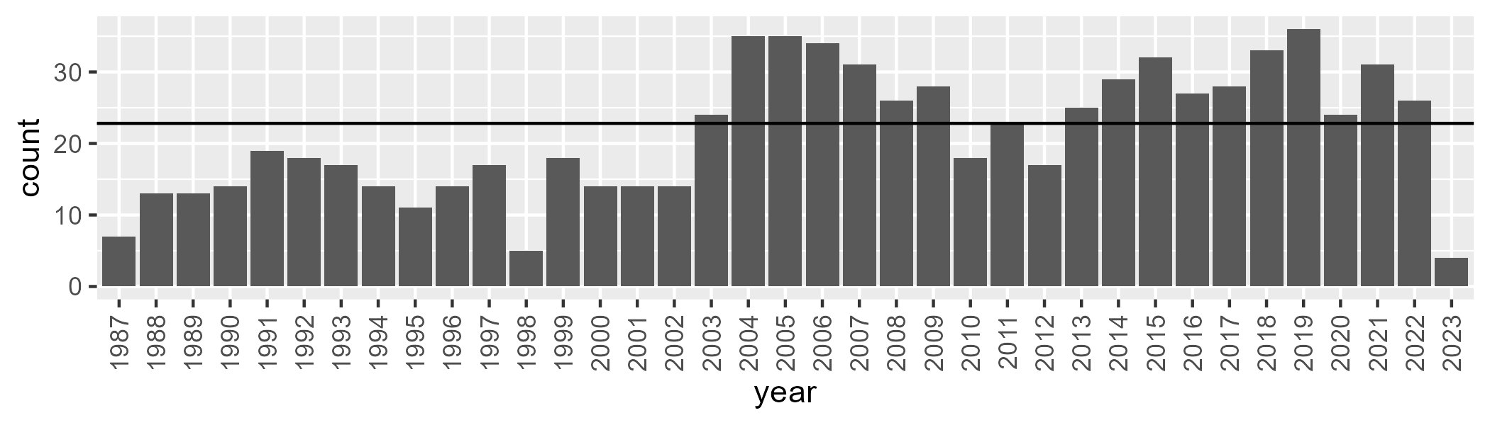

Number of samples: 788

# NSABBS0003

| Min. | 1st Qu. | Median | Mean | 3rd Qu. | Max. |
| --- | --- | --- | --- | --- | --- |
| 15.92857 | 36.64 | 41.8 | 41.38036 | 45.84 | 62.64 |

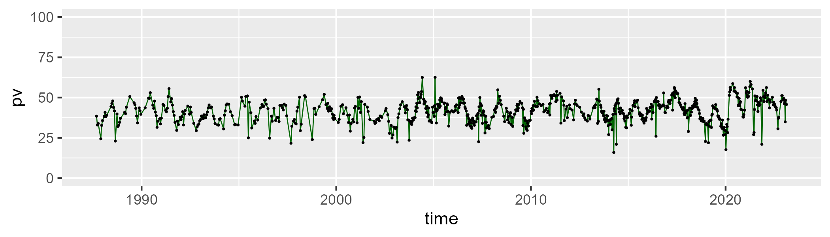

| Min. | 1st Qu. | Median | Mean | 3rd Qu. | Max. |
| --- | --- | --- | --- | --- | --- |
| 4 | 45.08 | 49.32 | 48.86571 | 53.76 | 78.75 |

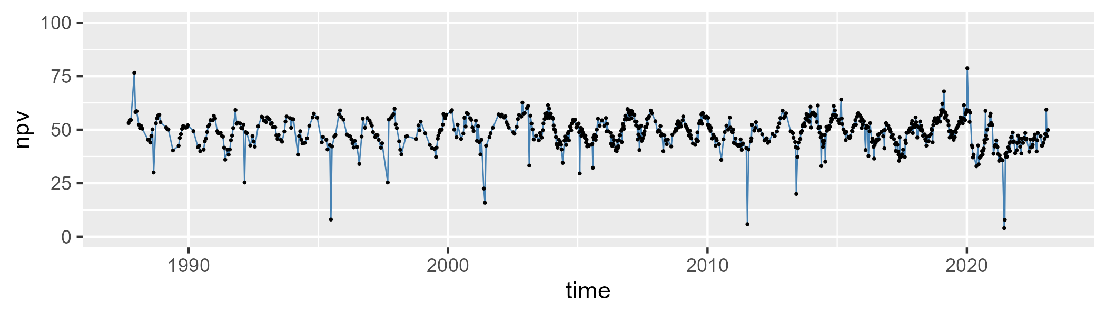

| Min. | 1st Qu. | Median | Mean | 3rd Qu. | Max. |
| --- | --- | --- | --- | --- | --- |
| 0 | 5.48 | 7.24 | 8.552385 | 9 | 69 |

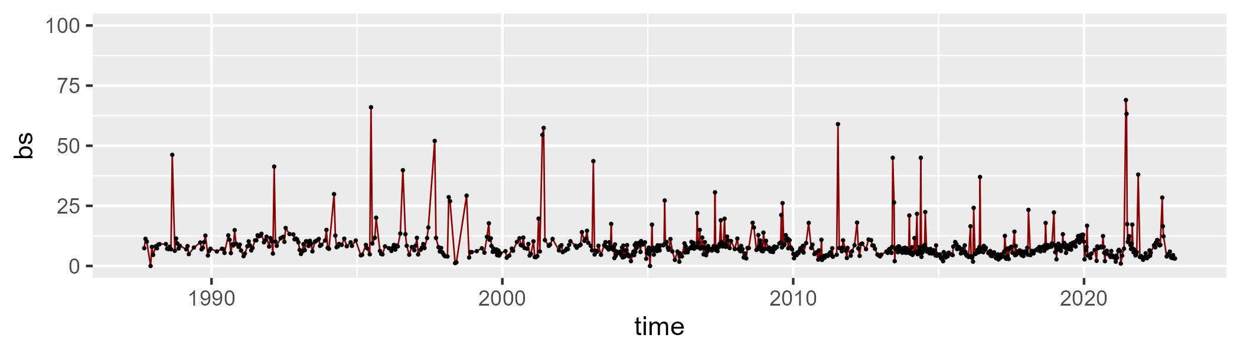

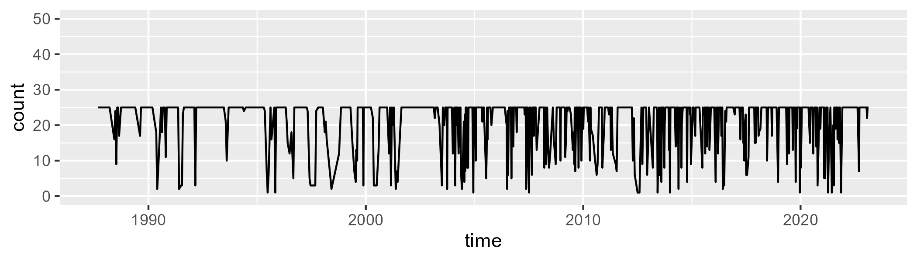

Min. : 1.00 1st Qu.:21.00 Median :25.00 Mean :21.41 3rd Qu.:25.00 Max. :25.00

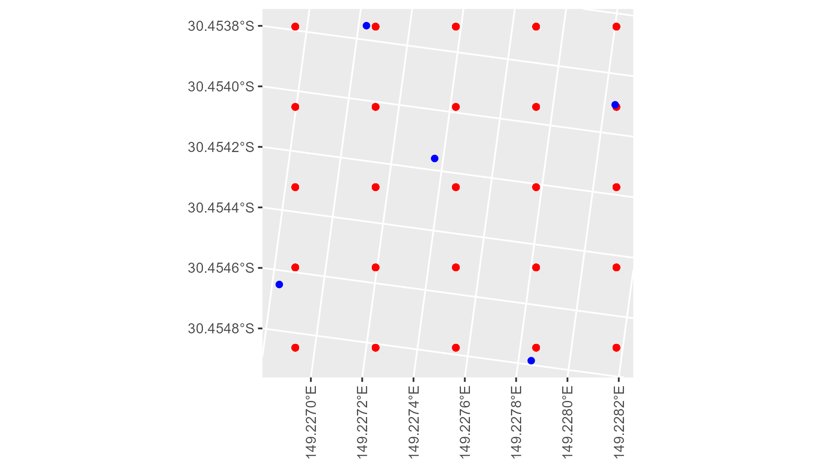

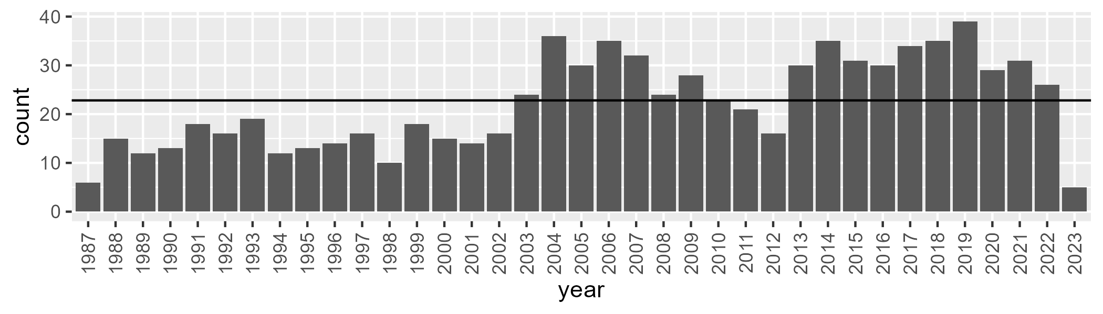

Number of samples: 821

# NSABBS0004

| Min. | 1st Qu. | Median | Mean | 3rd Qu. | Max. |
| --- | --- | --- | --- | --- | --- |
| 18 | 40.78 | 45.68 | 45.66657 | 50.86444 | 64.75 |

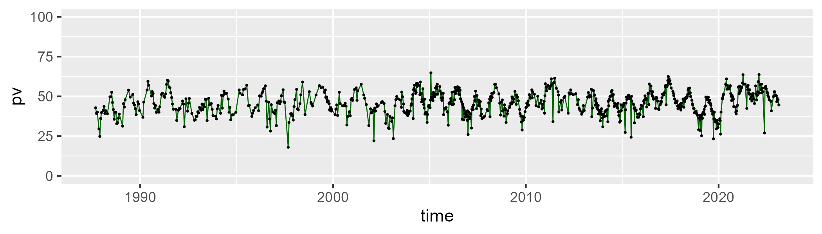

| Min. | 1st Qu. | Median | Mean | 3rd Qu. | Max. |
| --- | --- | --- | --- | --- | --- |
| 7.6 | 41.6 | 46.04 | 46.10514 | 51.1 | 76.12 |

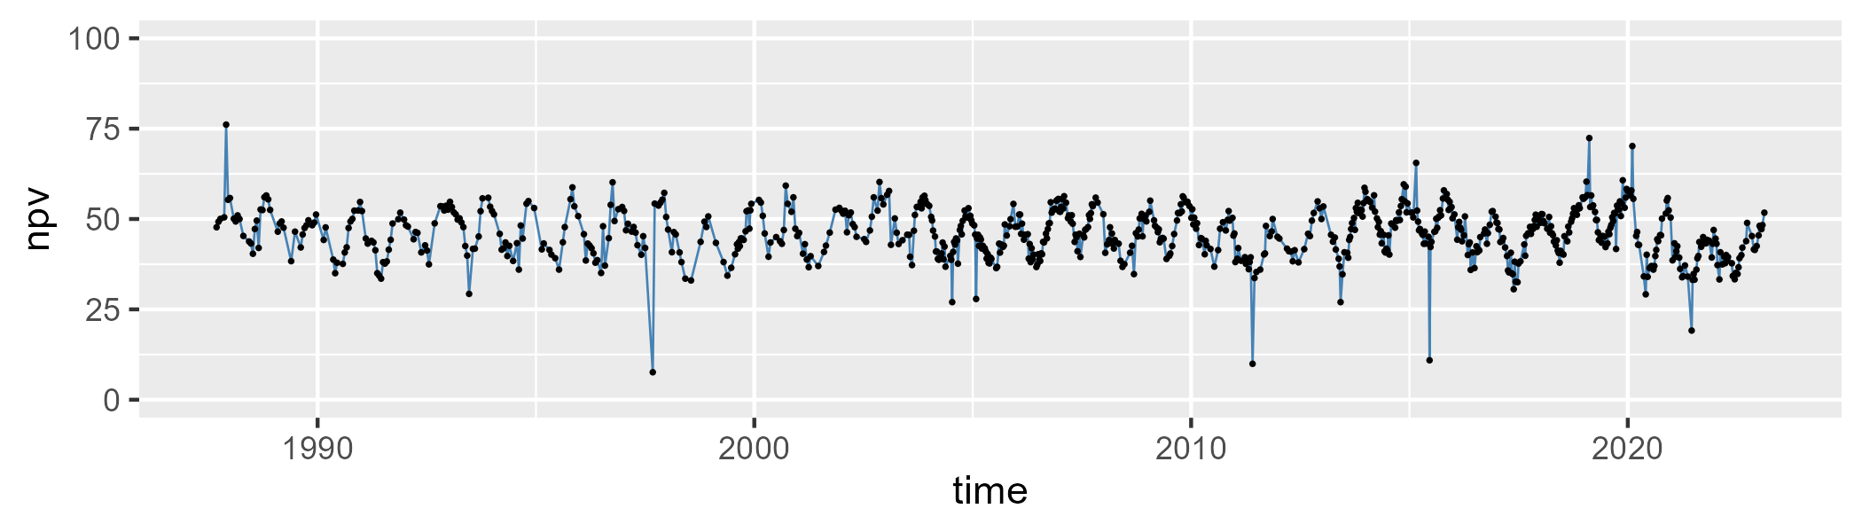

| Min. | 1st Qu. | Median | Mean | 3rd Qu. | Max. |
| --- | --- | --- | --- | --- | --- |
| 0 | 4.56 | 5.96 | 6.988555 | 7.6 | 73.6 |

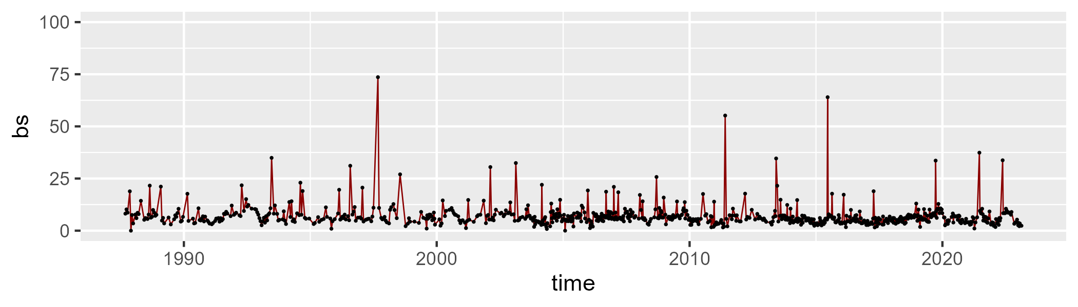

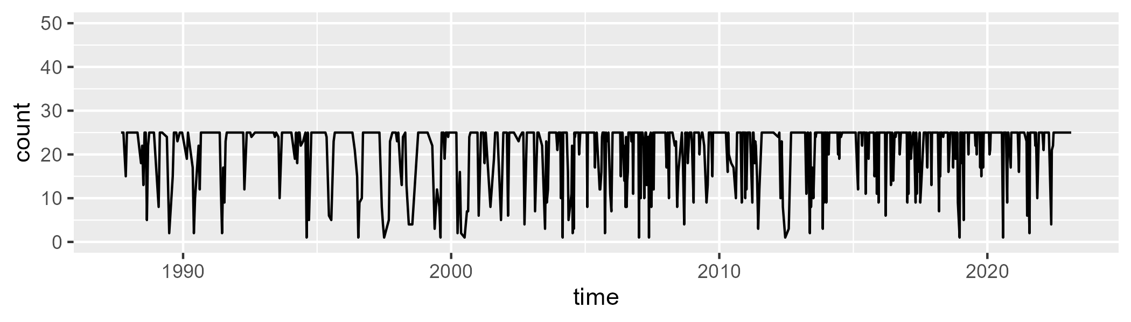

Min. : 1.00 1st Qu.:23.00 Median :25.00 Mean :21.78 3rd Qu.:25.00 Max. :25.00

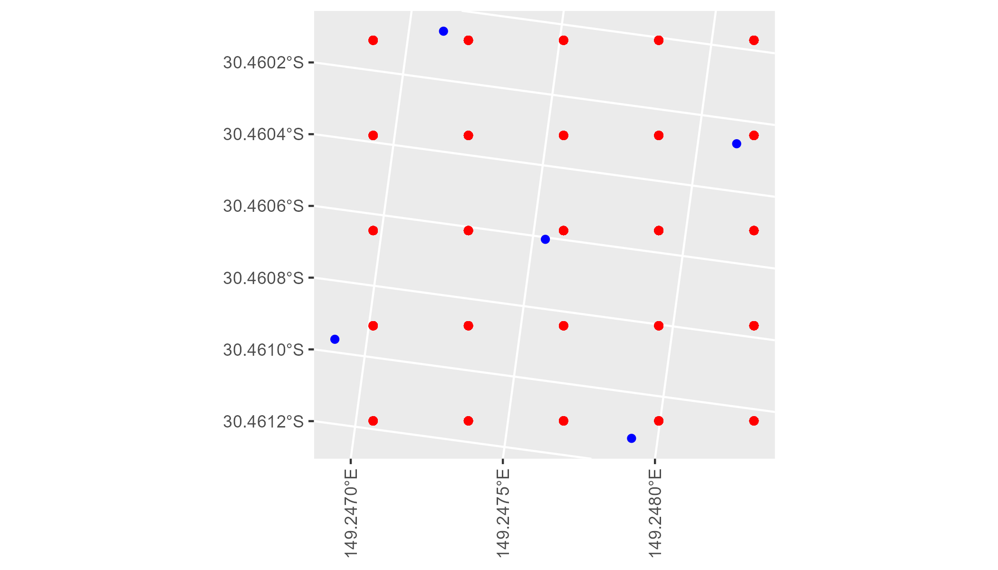

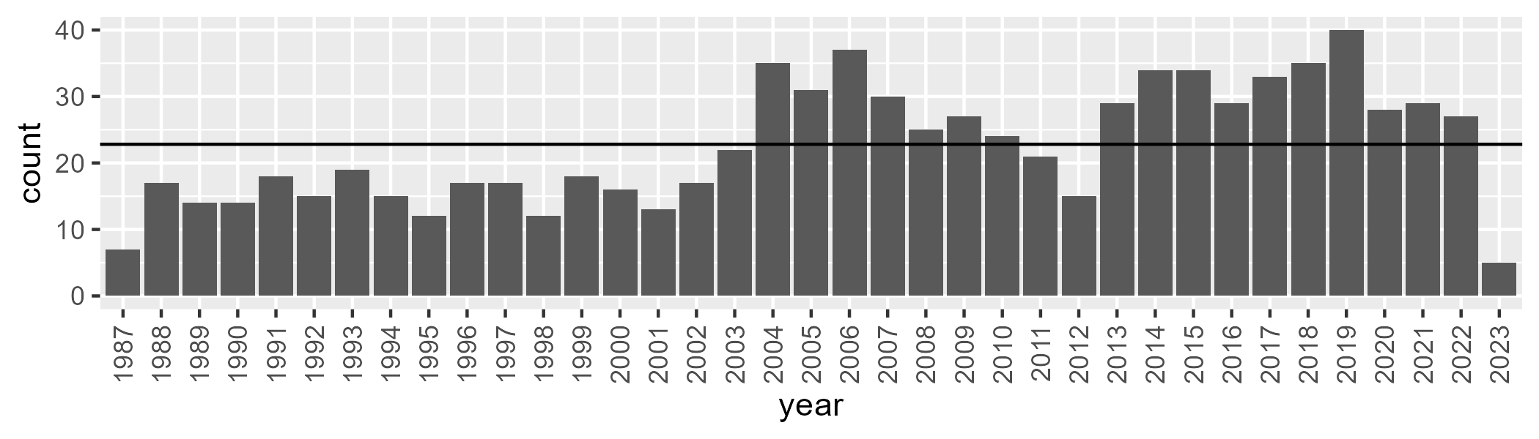

Number of samples: 831

# NSABBS0005

| Min. | 1st Qu. | Median | Mean | 3rd Qu. | Max. |
| --- | --- | --- | --- | --- | --- |
| 20.52174 | 38.475 | 43.42719 | 42.96769 | 47.59773 | 65.6 |

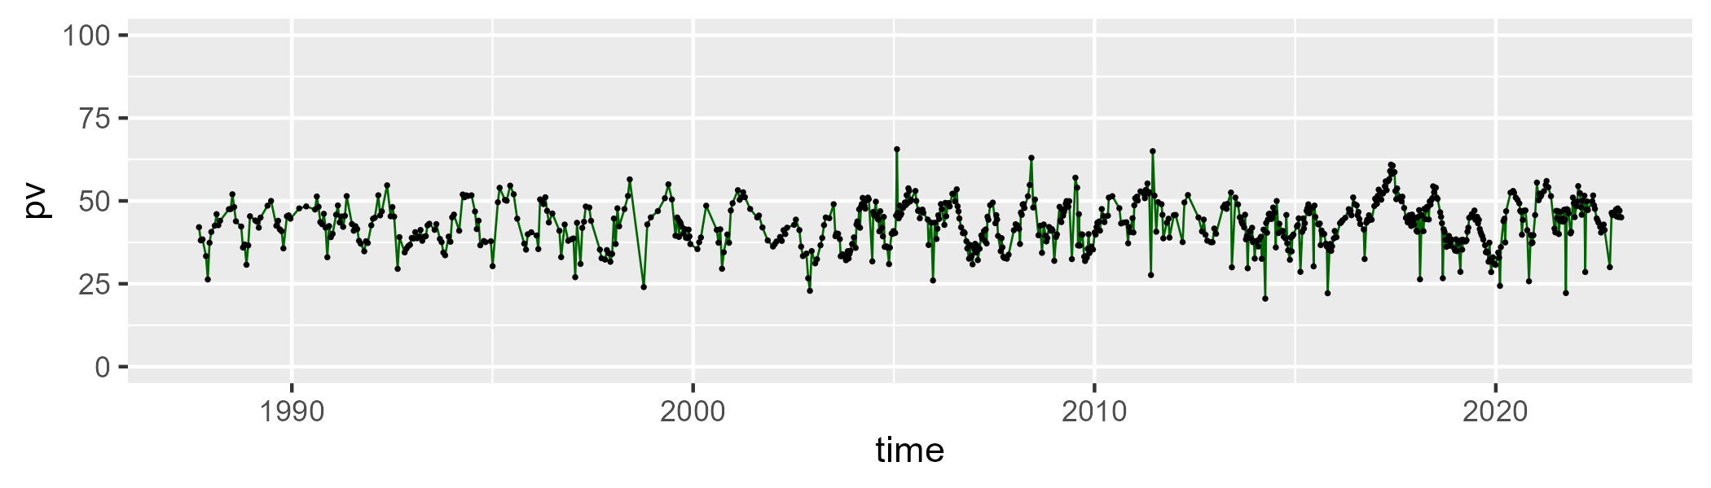

| Min. | 1st Qu. | Median | Mean | 3rd Qu. | Max. |
| --- | --- | --- | --- | --- | --- |
| 0 | 44 | 48.0359 | 47.94129 | 52.95437 | 74.86667 |

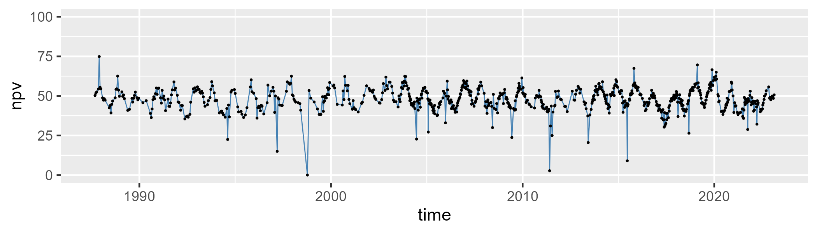

| Min. | 1st Qu. | Median | Mean | 3rd Qu. | Max. |
| --- | --- | --- | --- | --- | --- |
| 0 | 5.241667 | 6.697826 | 7.903002 | 8.425 | 76 |

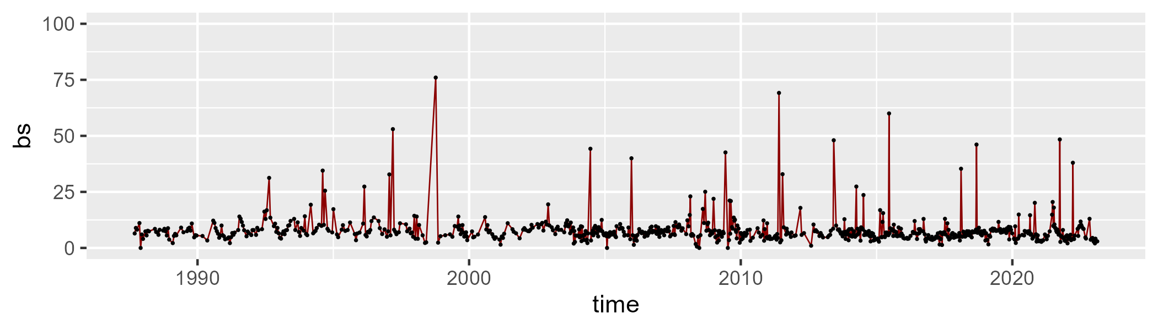

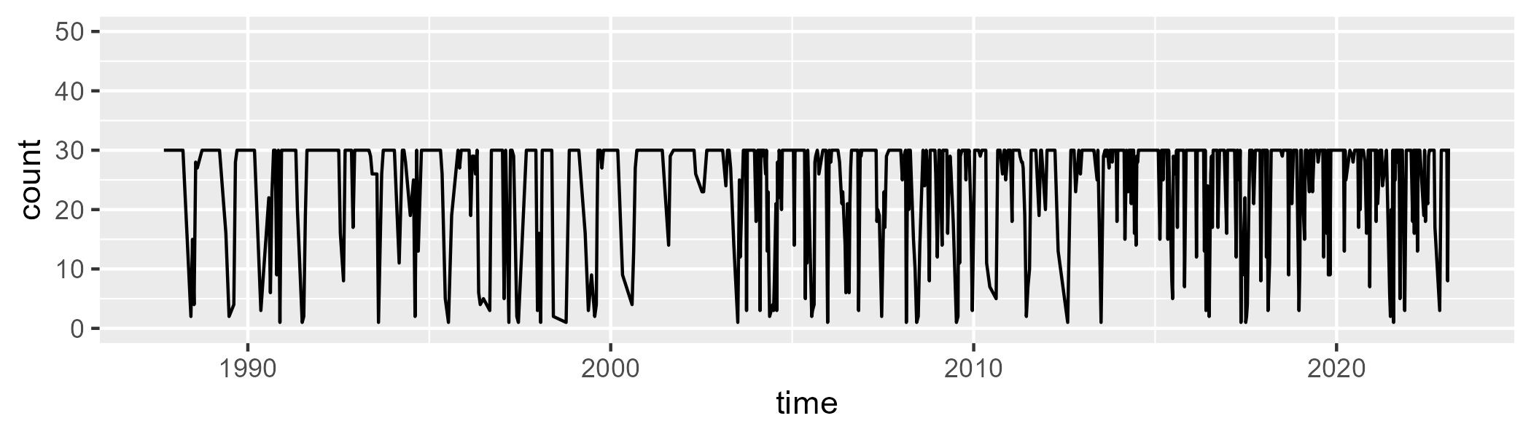

Min. : 1.0 1st Qu.:24.0 Median :30.0 Mean :25.1 3rd Qu.:30.0 Max. :30.0

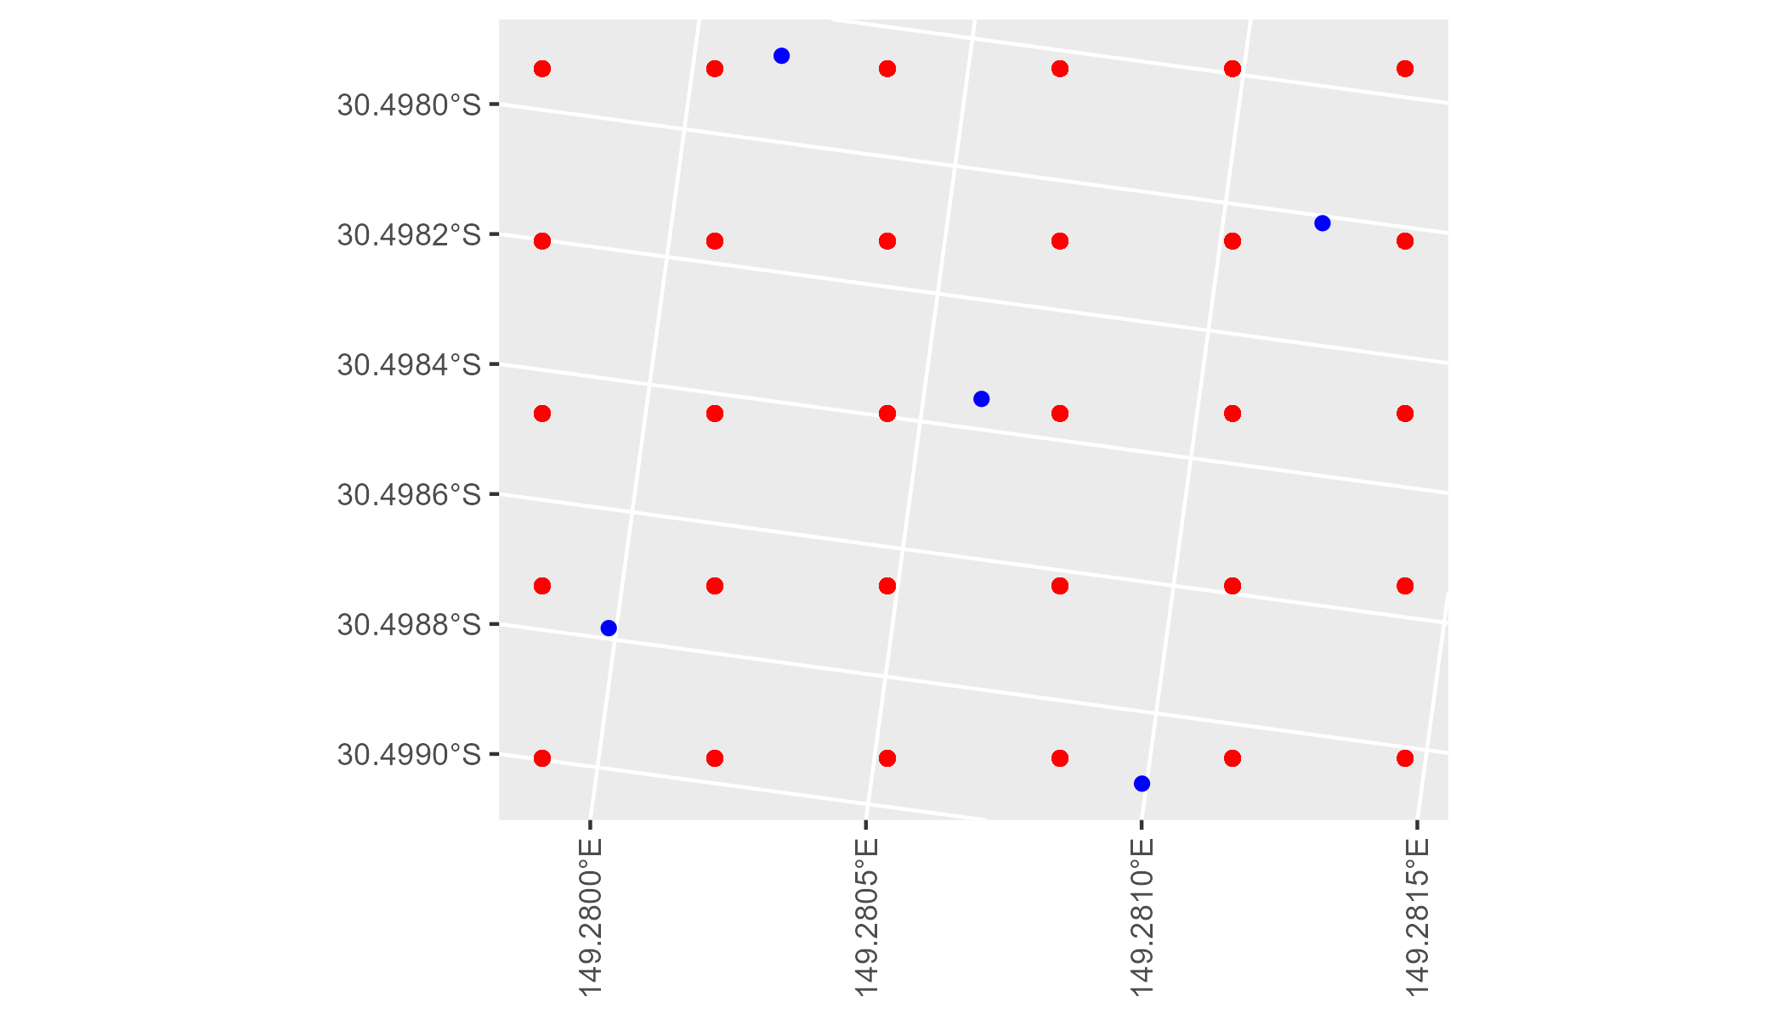

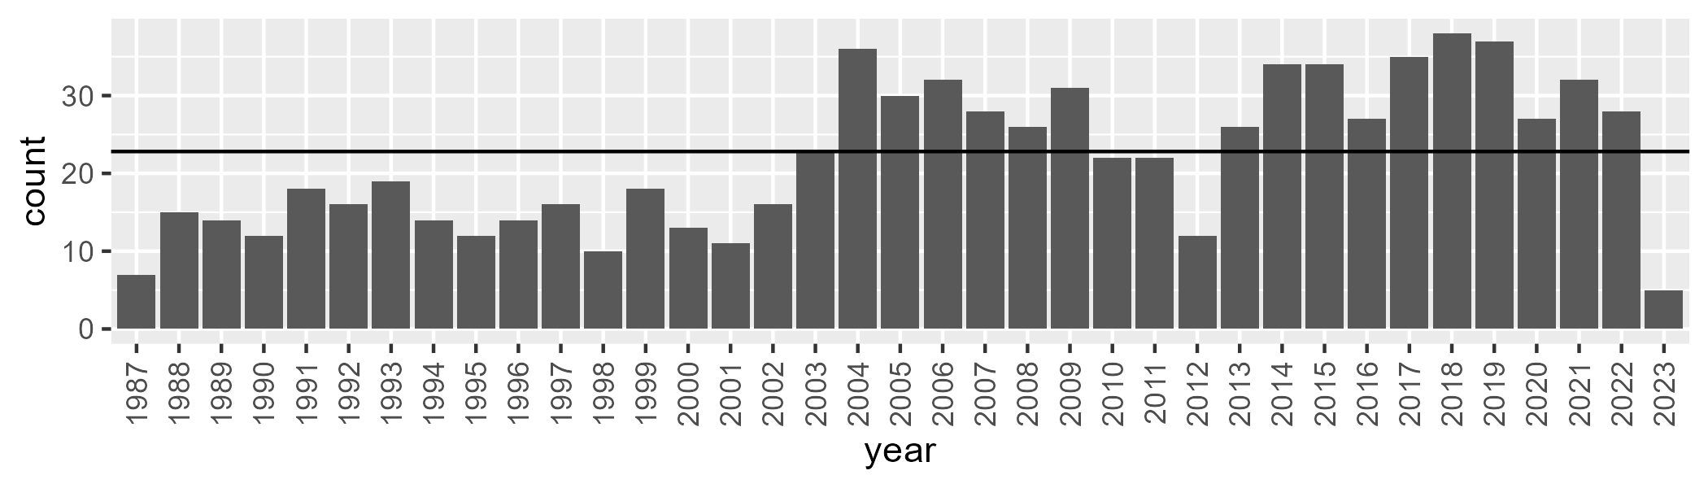

Number of samples: 810

# NSABBS0006

| Min. | 1st Qu. | Median | Mean | 3rd Qu. | Max. |
| --- | --- | --- | --- | --- | --- |
| 17.83333 | 40.71 | 45.67333 | 45.22738 | 50.2575 | 66.5 |

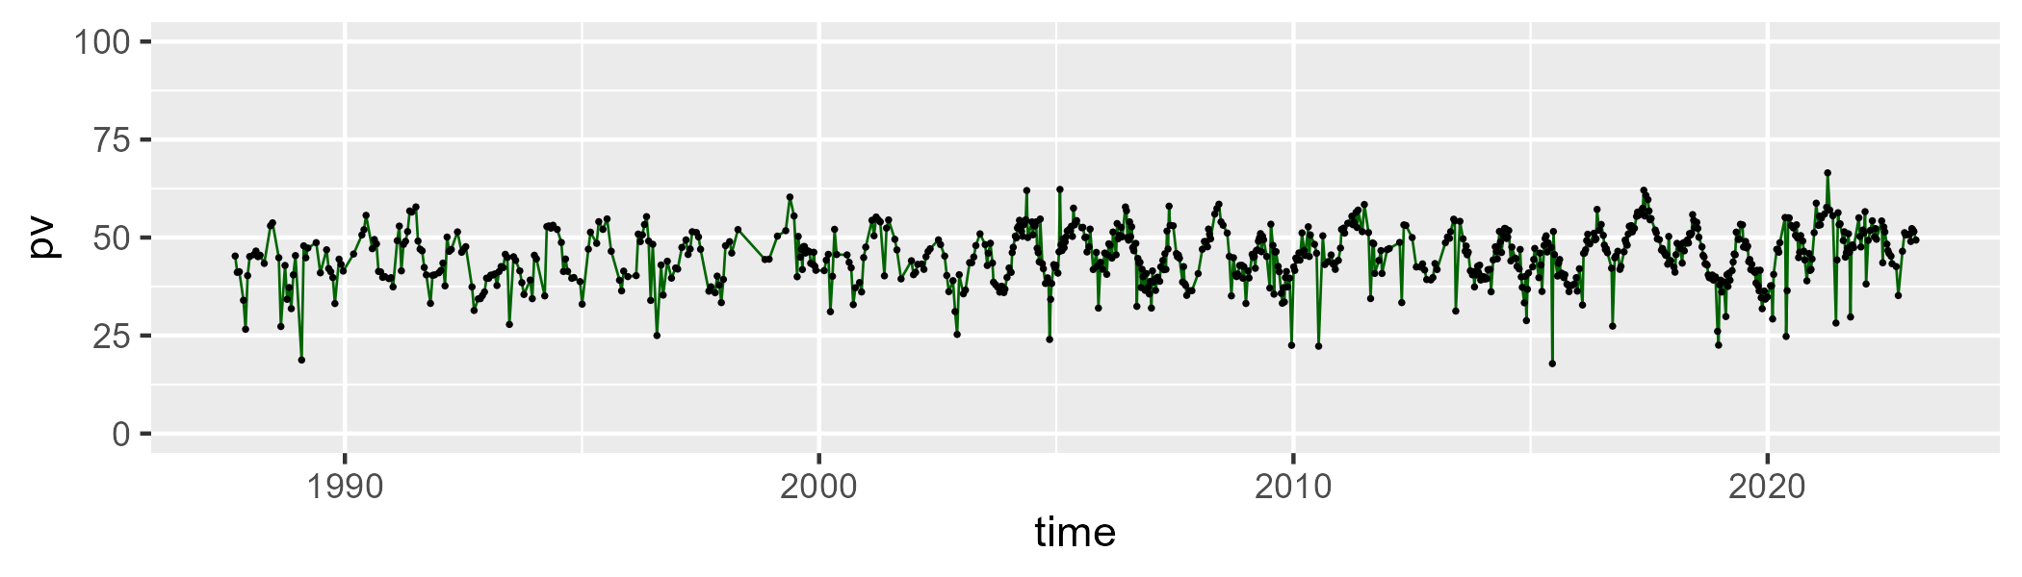

| Min. | 1st Qu. | Median | Mean | 3rd Qu. | Max. |
| --- | --- | --- | --- | --- | --- |
| 0.1666667 | 42.36 | 46.14 | 46.22924 | 50.96 | 74.36 |

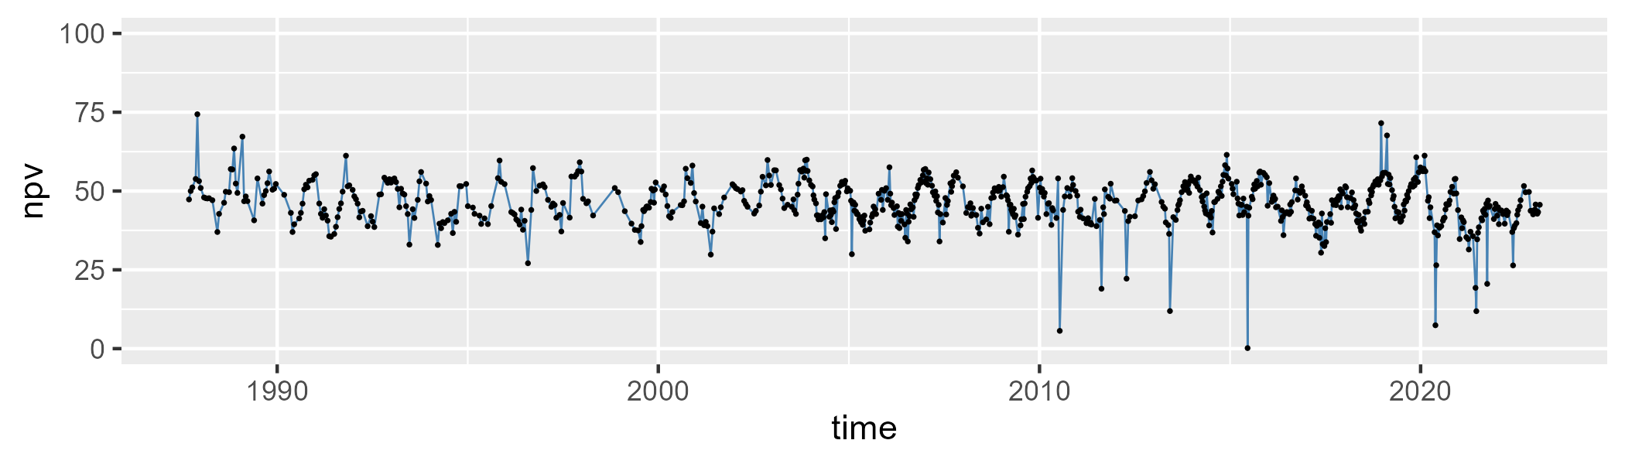

| Min. | 1st Qu. | Median | Mean | 3rd Qu. | Max. |
| --- | --- | --- | --- | --- | --- |
| 0 | 4.76 | 6.04 | 7.340549 | 7.6 | 81.5 |

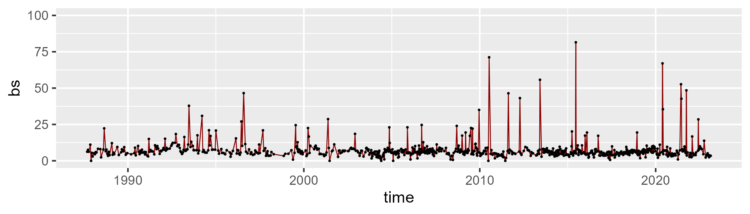

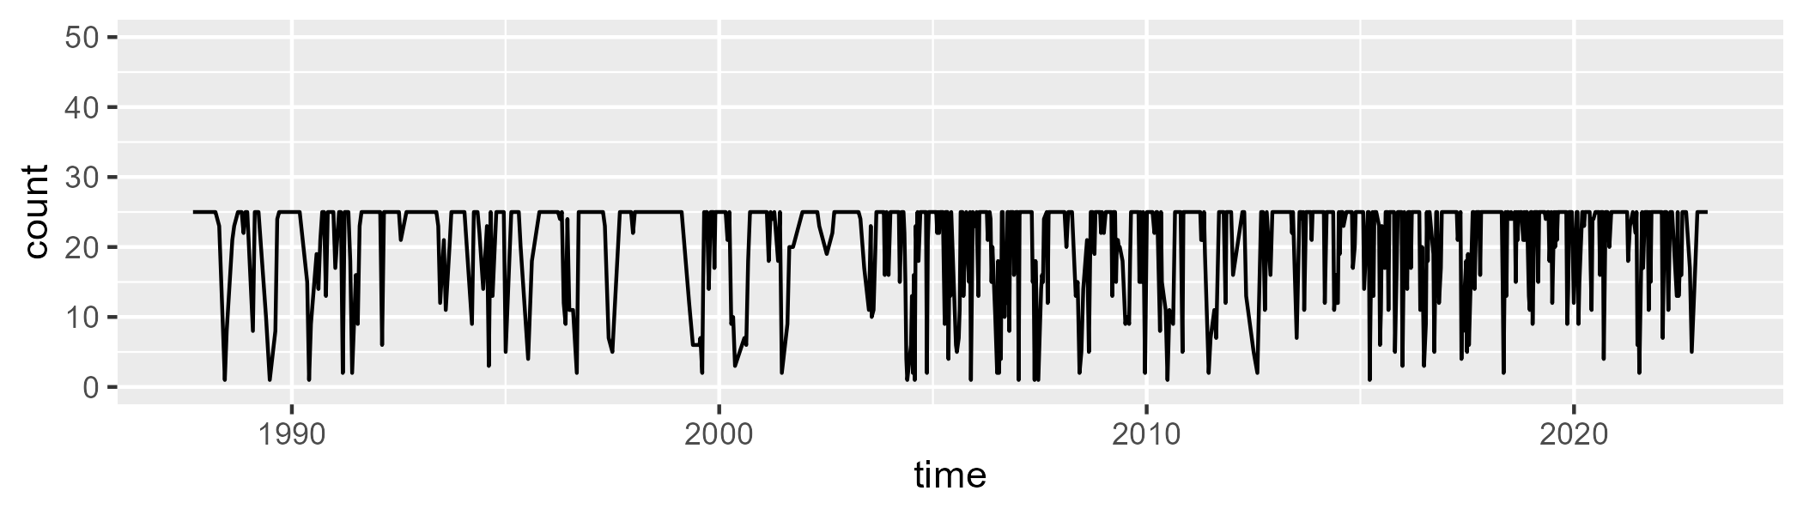

Min. : 1.00 1st Qu.:18.00 Median :25.00 Mean :20.79 3rd Qu.:25.00 Max. :25.00

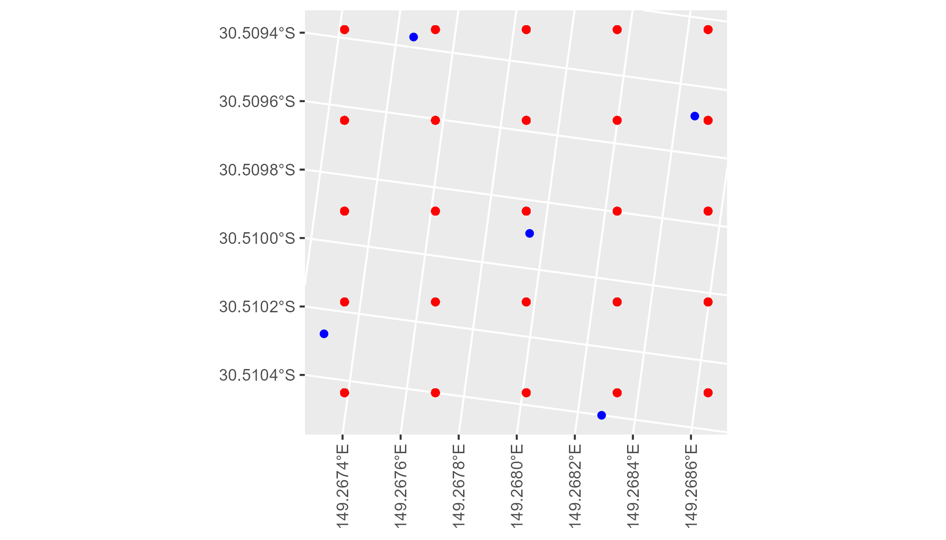

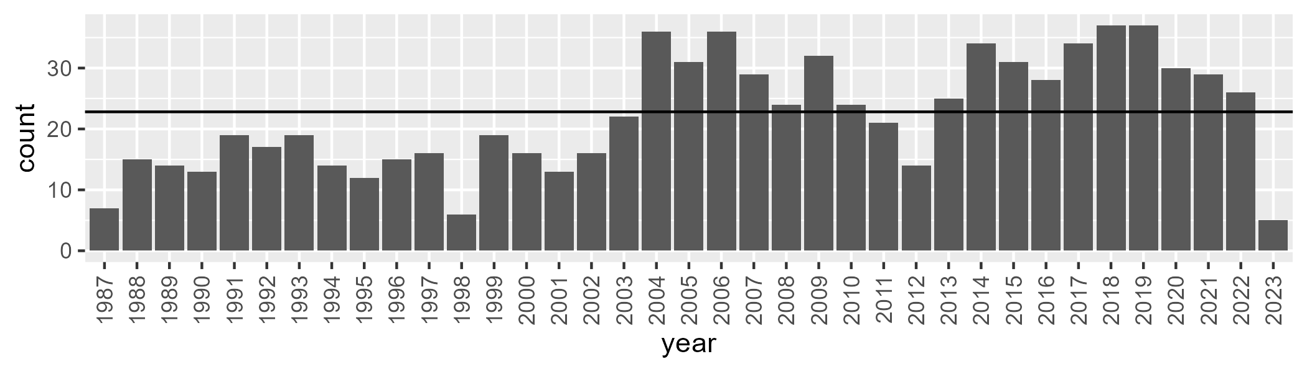

Number of samples: 816

# NSABHC0001

| Min. | 1st Qu. | Median | Mean | 3rd Qu. | Max. |
| --- | --- | --- | --- | --- | --- |
| 0 | 5.8 | 8.6 | 9.955772 | 13.31 | 34.16 |

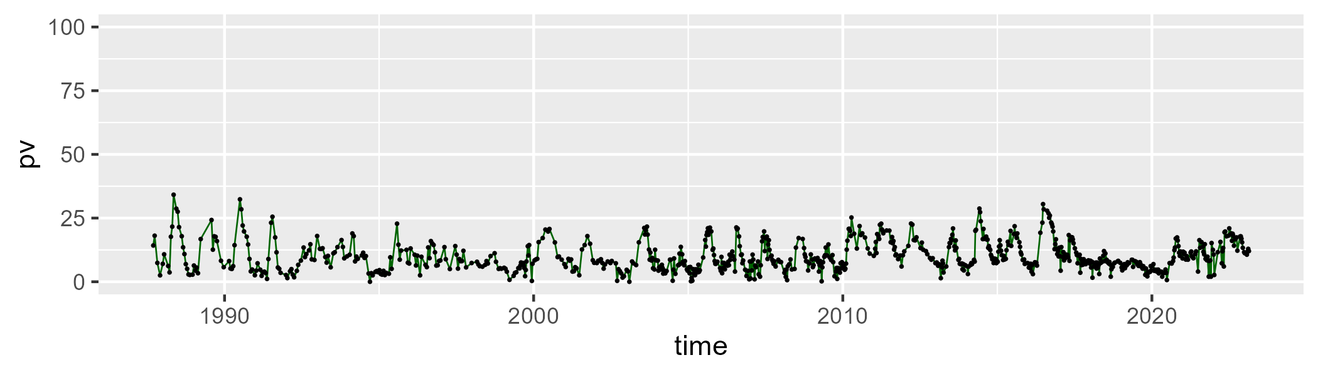

| Min. | 1st Qu. | Median | Mean | 3rd Qu. | Max. |
| --- | --- | --- | --- | --- | --- |
| 4.96 | 31.8 | 36.88 | 37.42934 | 42.51 | 77.5 |

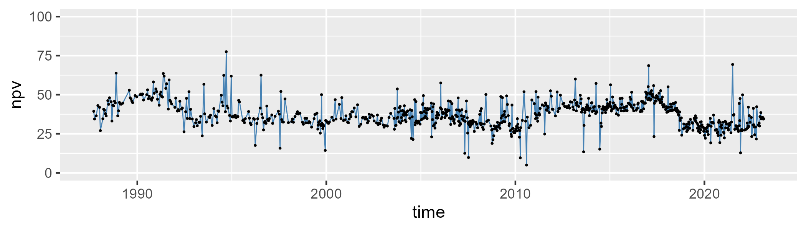

| Min. | 1st Qu. | Median | Mean | 3rd Qu. | Max. |
| --- | --- | --- | --- | --- | --- |
| 16.28 | 45 | 51.77286 | 51.0988 | 58 | 84 |

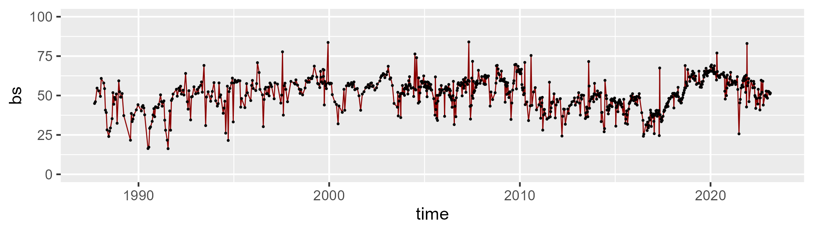

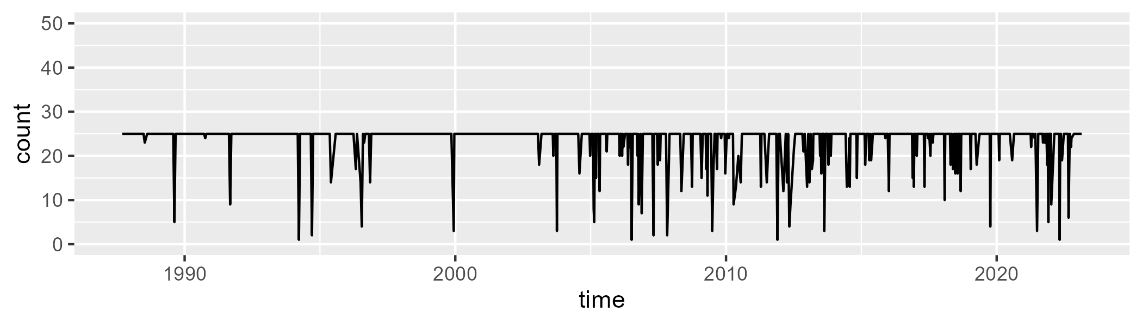

Min. : 1.0 1st Qu.:25.0 Median :25.0 Mean :23.6 3rd Qu.:25.0 Max. :25.0

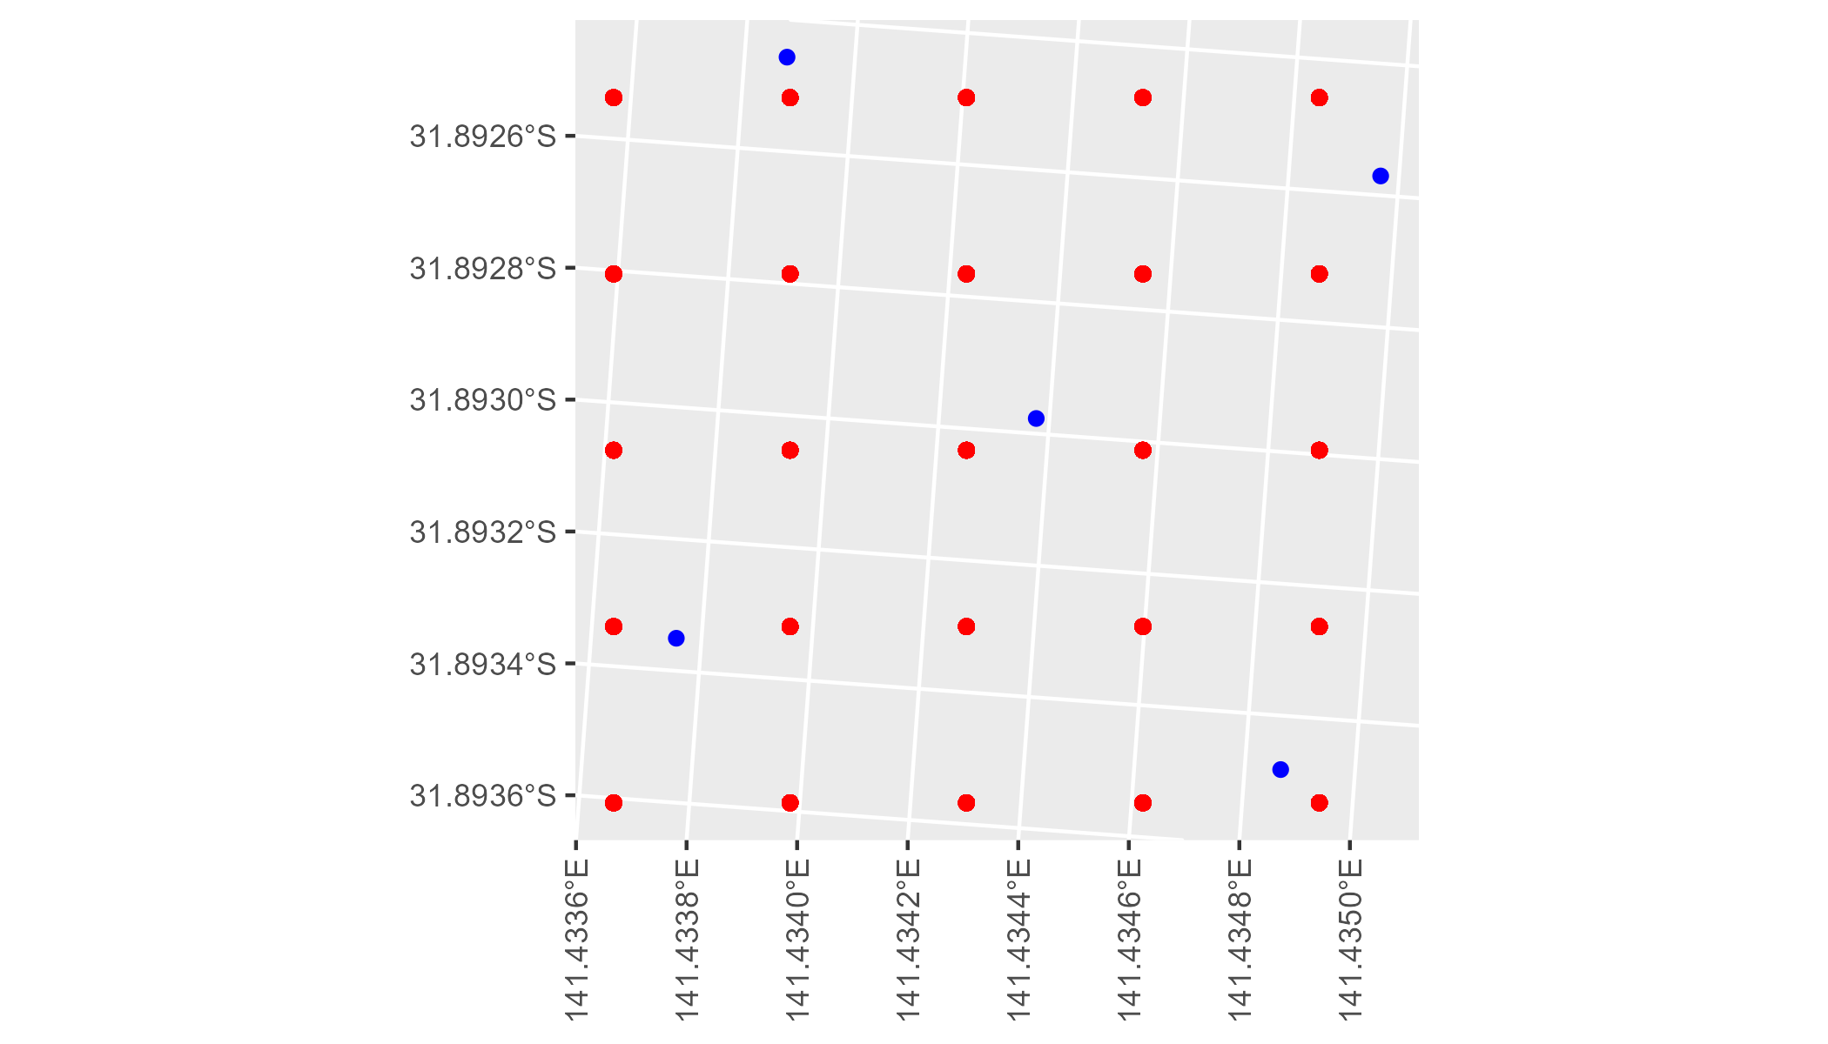

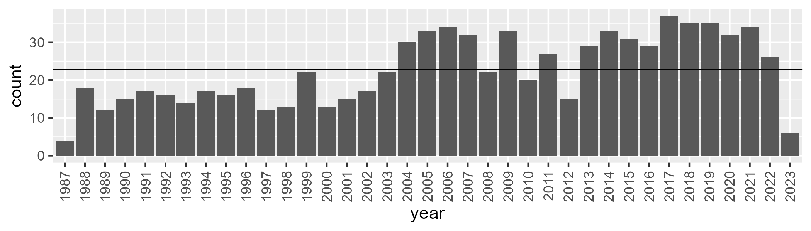

Number of samples: 834

# NSABHC0002

| Min. | 1st Qu. | Median | Mean | 3rd Qu. | Max. |
| --- | --- | --- | --- | --- | --- |
| 0 | 5.3 | 8 | 9.567766 | 12.6 | 33.7 |

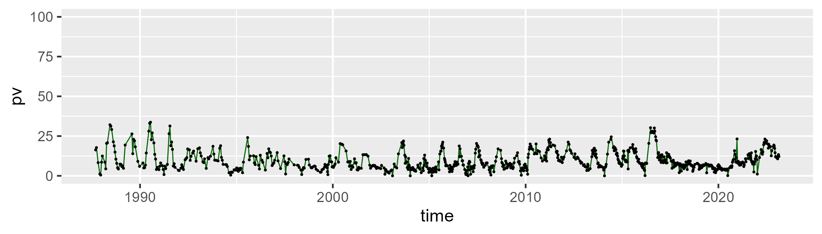

| Min. | 1st Qu. | Median | Mean | 3rd Qu. | Max. |
| --- | --- | --- | --- | --- | --- |
| 19.66667 | 34.55 | 39.9 | 40.01837 | 45.35294 | 78.54545 |

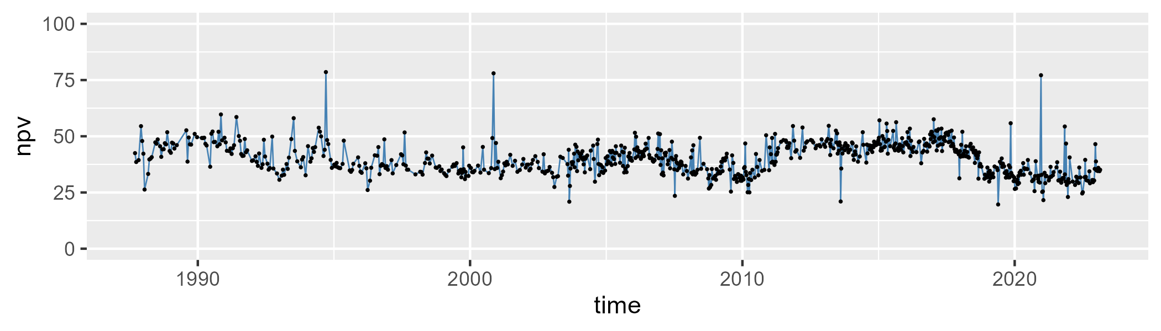

| Min. | 1st Qu. | Median | Mean | 3rd Qu. | Max. |
| --- | --- | --- | --- | --- | --- |
| 0 | 43.125 | 50 | 48.92588 | 56.1 | 76.58333 |

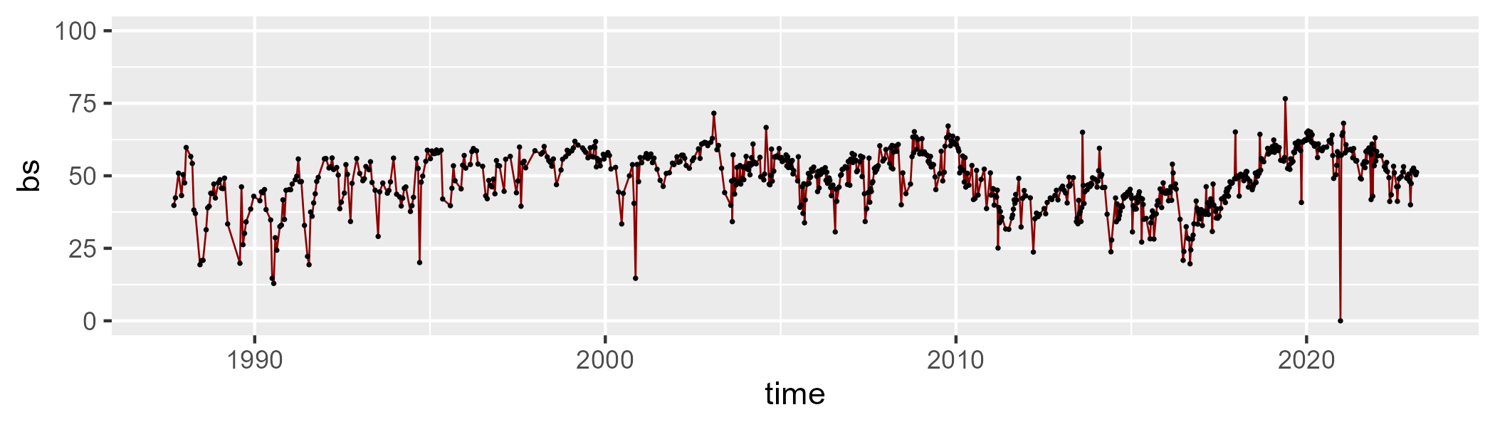

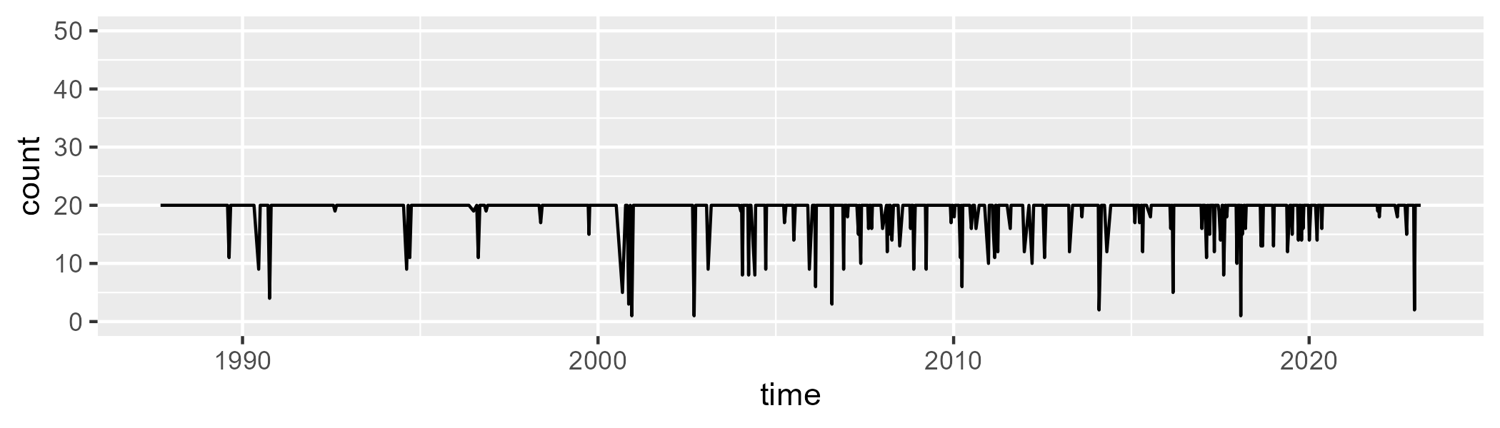

Min. : 1.00 1st Qu.:20.00 Median :20.00 Mean :19.14 3rd Qu.:20.00 Max. :20.00

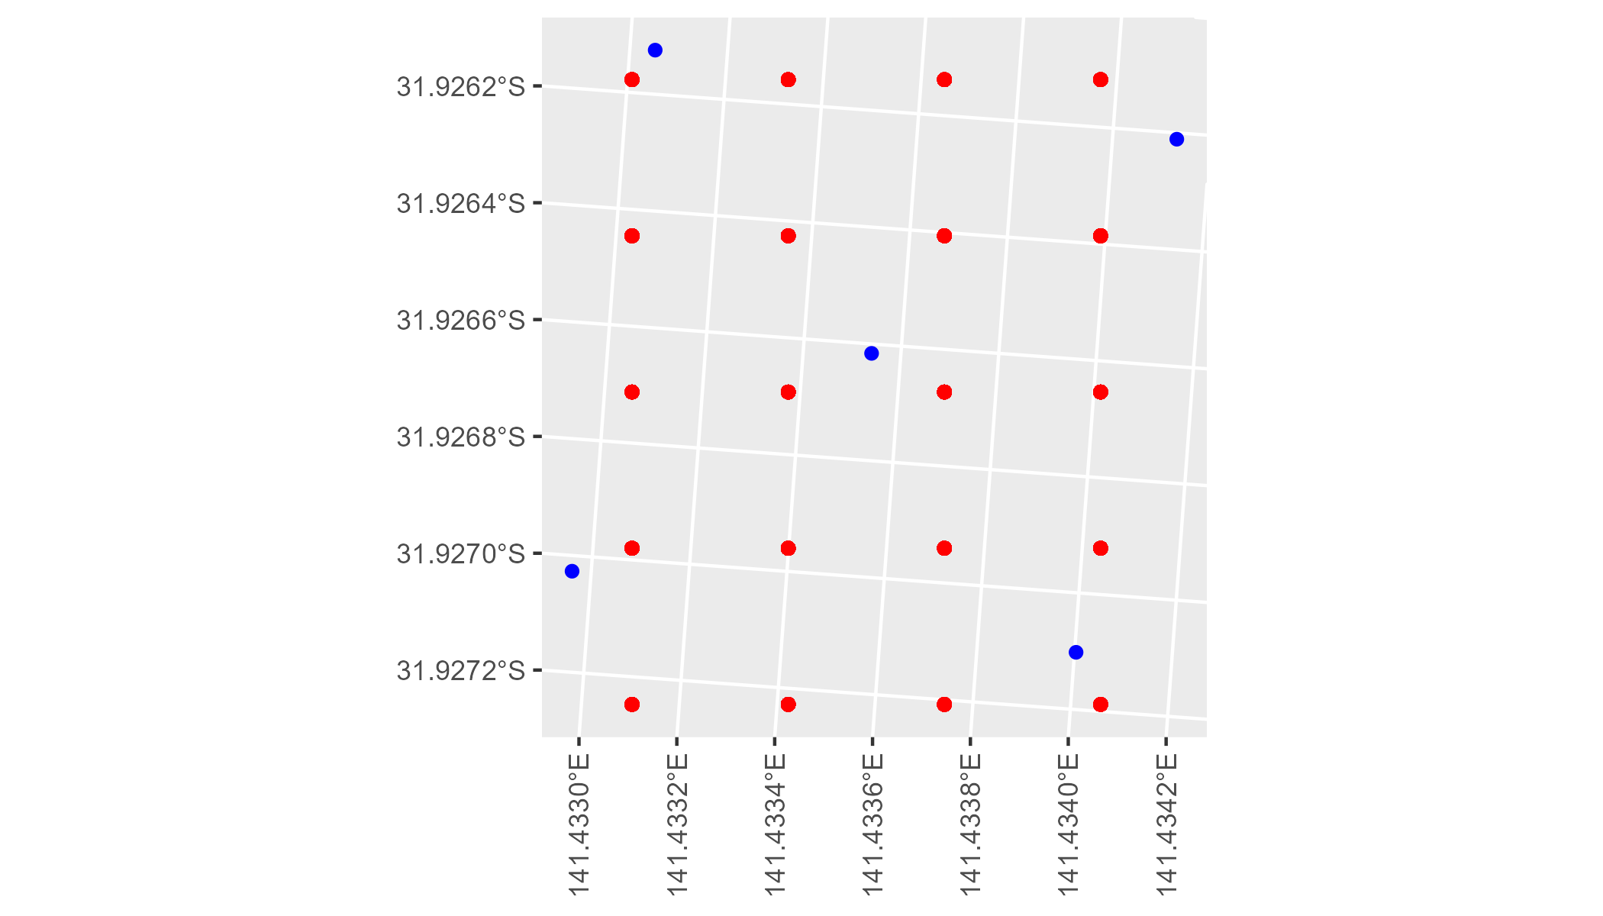

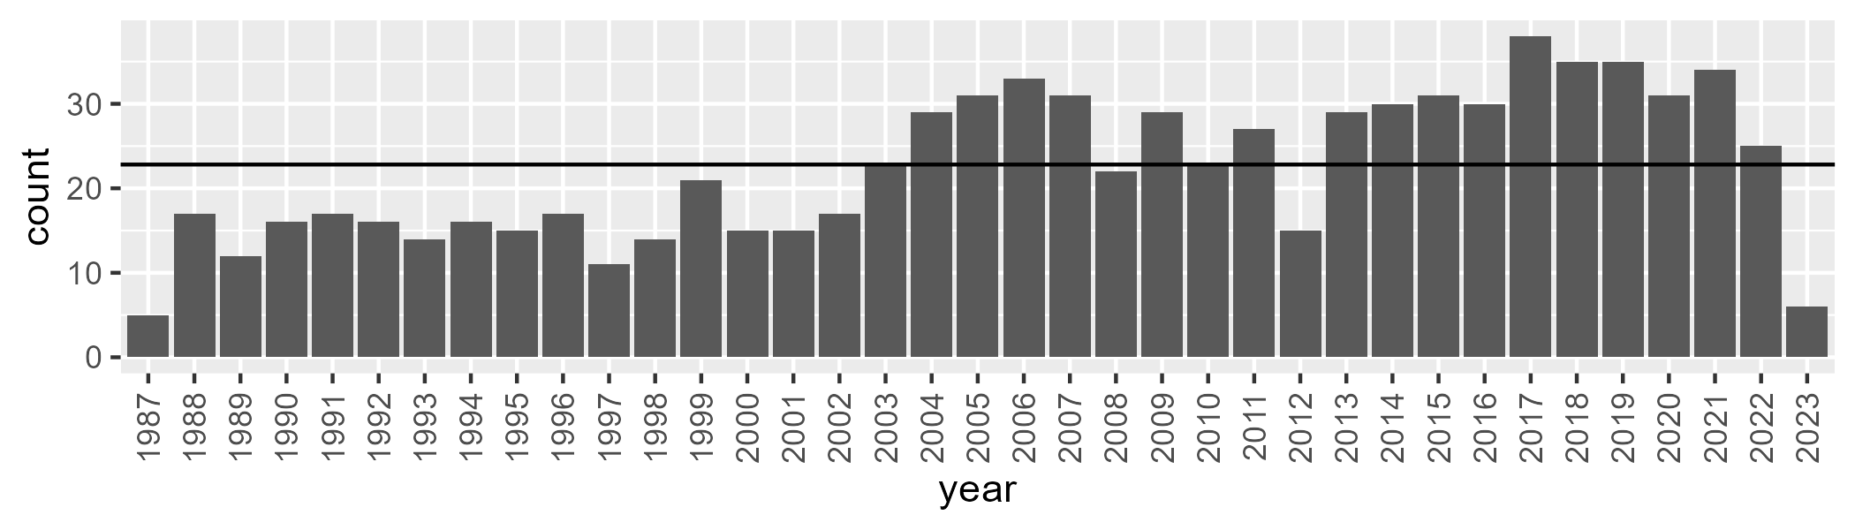

Number of samples: 825

# NSABHC0003

| Min. | 1st Qu. | Median | Mean | 3rd Qu. | Max. |
| --- | --- | --- | --- | --- | --- |
| 0 | 6.2 | 8.24 | 9.314271 | 12.06 | 29.92 |

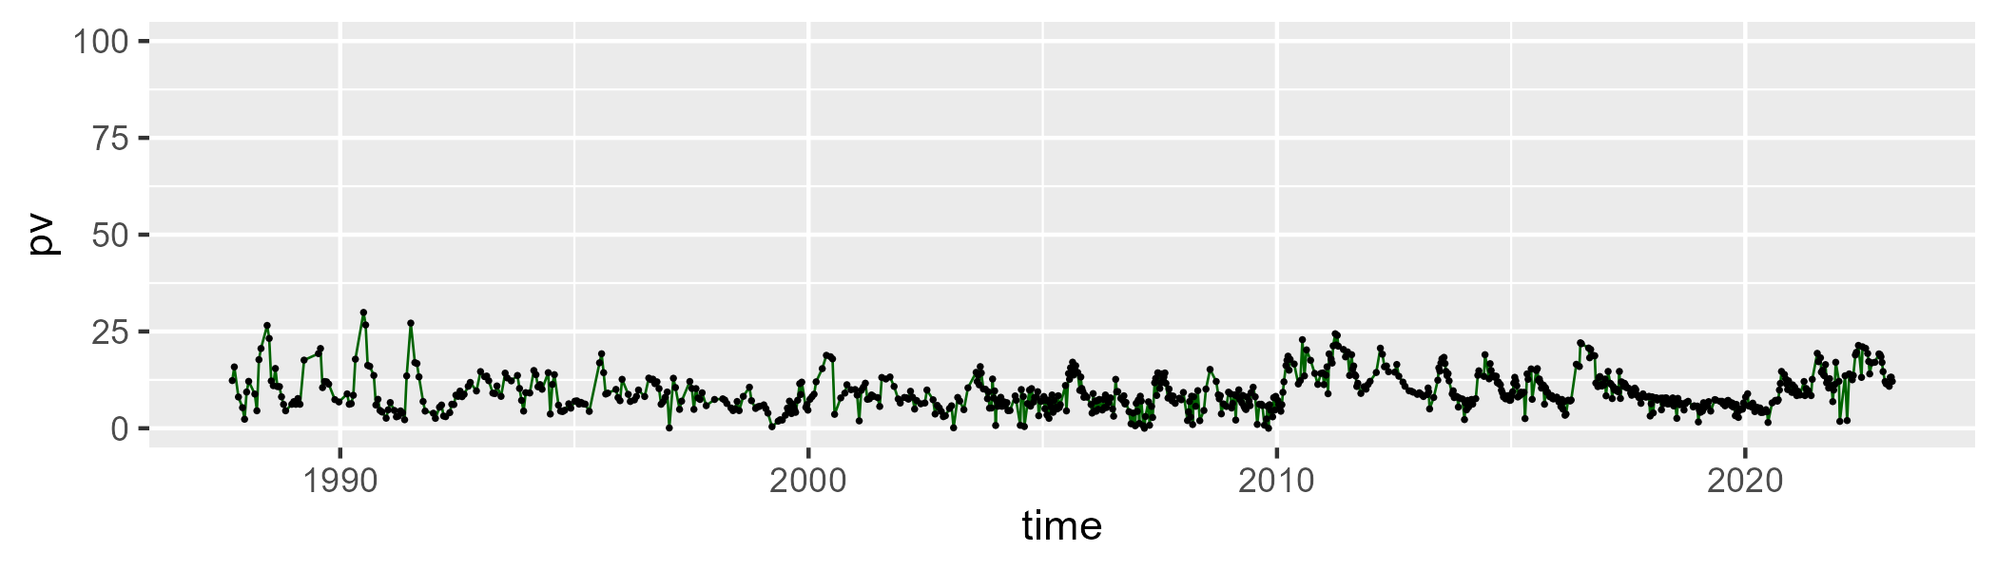

| Min. | 1st Qu. | Median | Mean | 3rd Qu. | Max. |
| --- | --- | --- | --- | --- | --- |
| 3.96 | 25.65 | 29.64 | 30.30764 | 33.56 | 95.71429 |

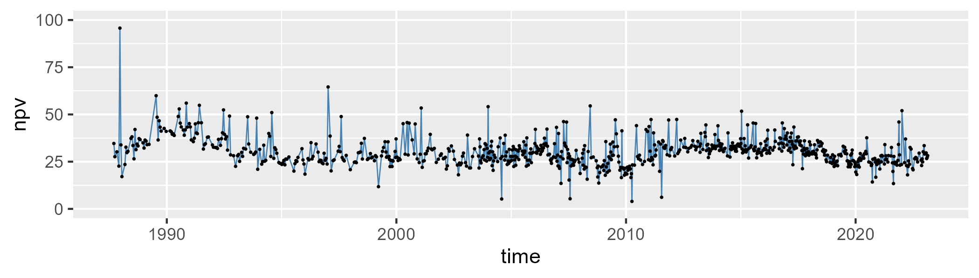

| Min. | 1st Qu. | Median | Mean | 3rd Qu. | Max. |
| --- | --- | --- | --- | --- | --- |
| 0 | 54.93 | 59.84 | 58.82498 | 64.55 | 86.8 |

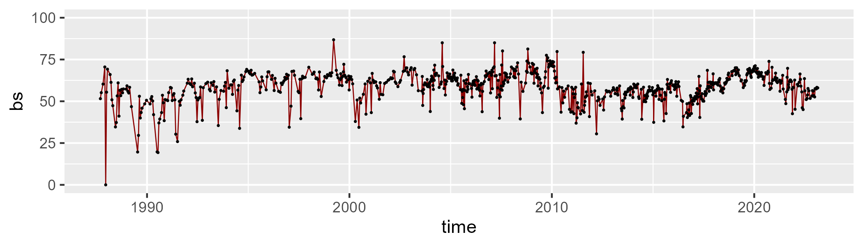

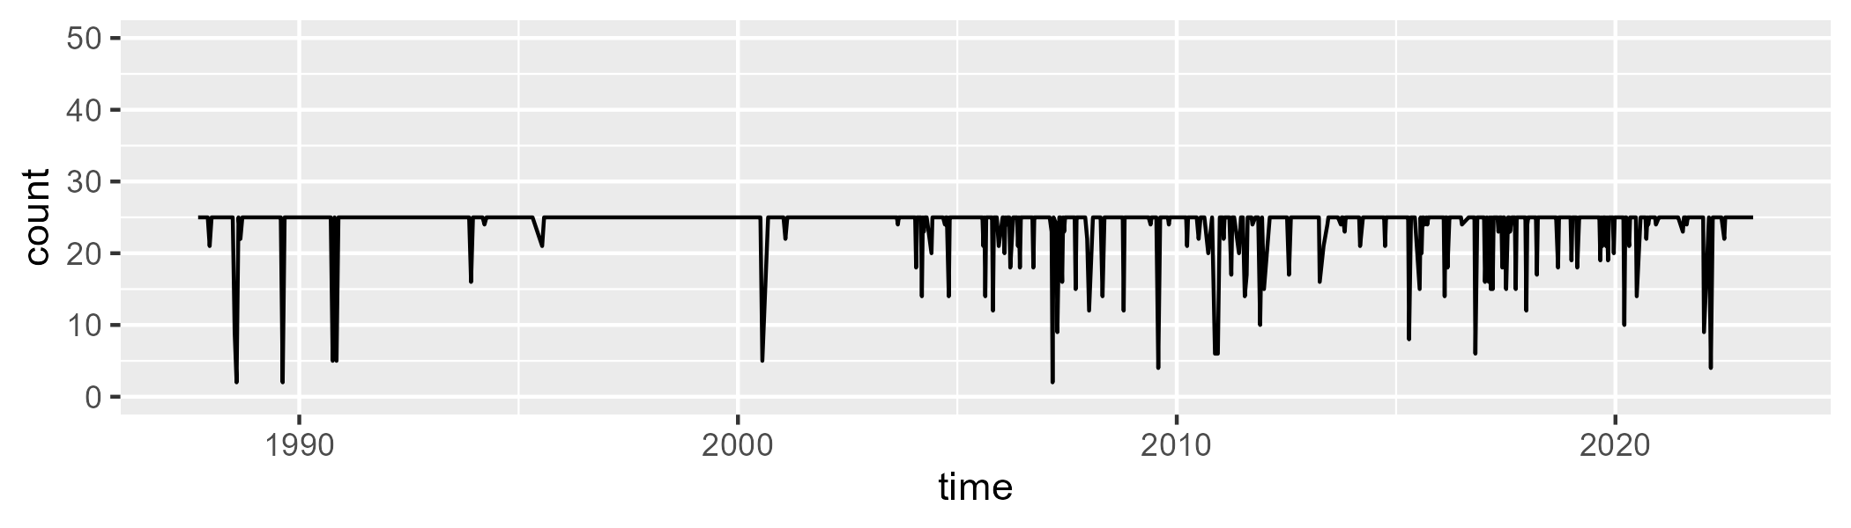

Min. : 2.00 1st Qu.:25.00 Median :25.00 Mean :24.04 3rd Qu.:25.00 Max. :25.00

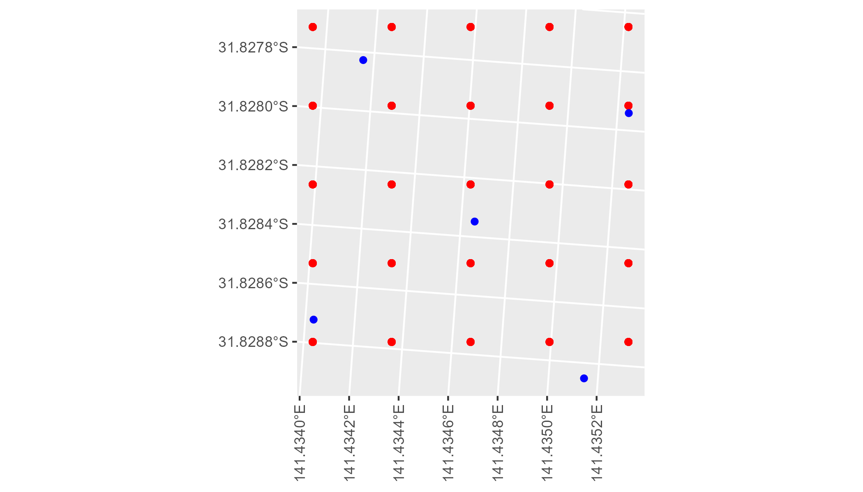

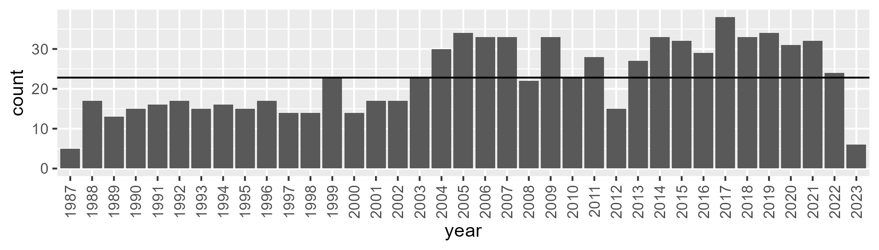

Number of samples: 838

# NSABHC0004

| Min. | 1st Qu. | Median | Mean | 3rd Qu. | Max. |
| --- | --- | --- | --- | --- | --- |
| 0 | 4.67 | 8.4 | 12.76744 | 18.30429 | 52.52 |

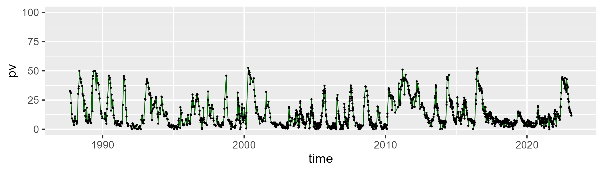

| Min. | 1st Qu. | Median | Mean | 3rd Qu. | Max. |
| --- | --- | --- | --- | --- | --- |
| 3.68 | 35.36 | 41.96 | 41.36068 | 47.8 | 100.2222 |

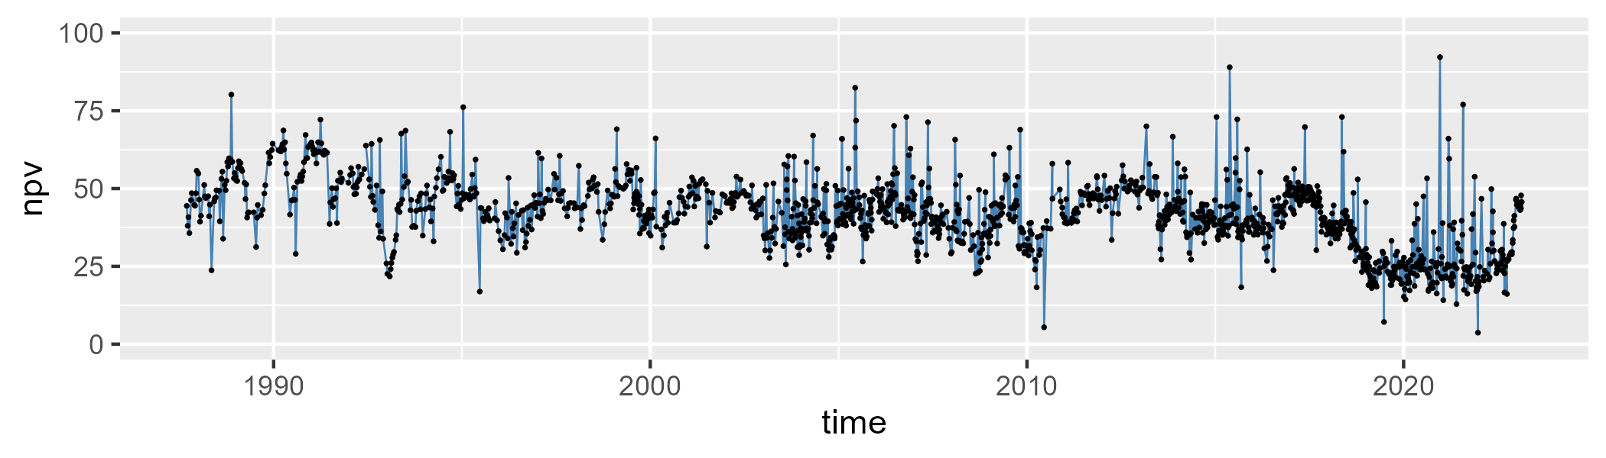

| Min. | 1st Qu. | Median | Mean | 3rd Qu. | Max. |
| --- | --- | --- | --- | --- | --- |
| 0 | 34.15 | 45.58 | 44.41904 | 54.16 | 80.3 |

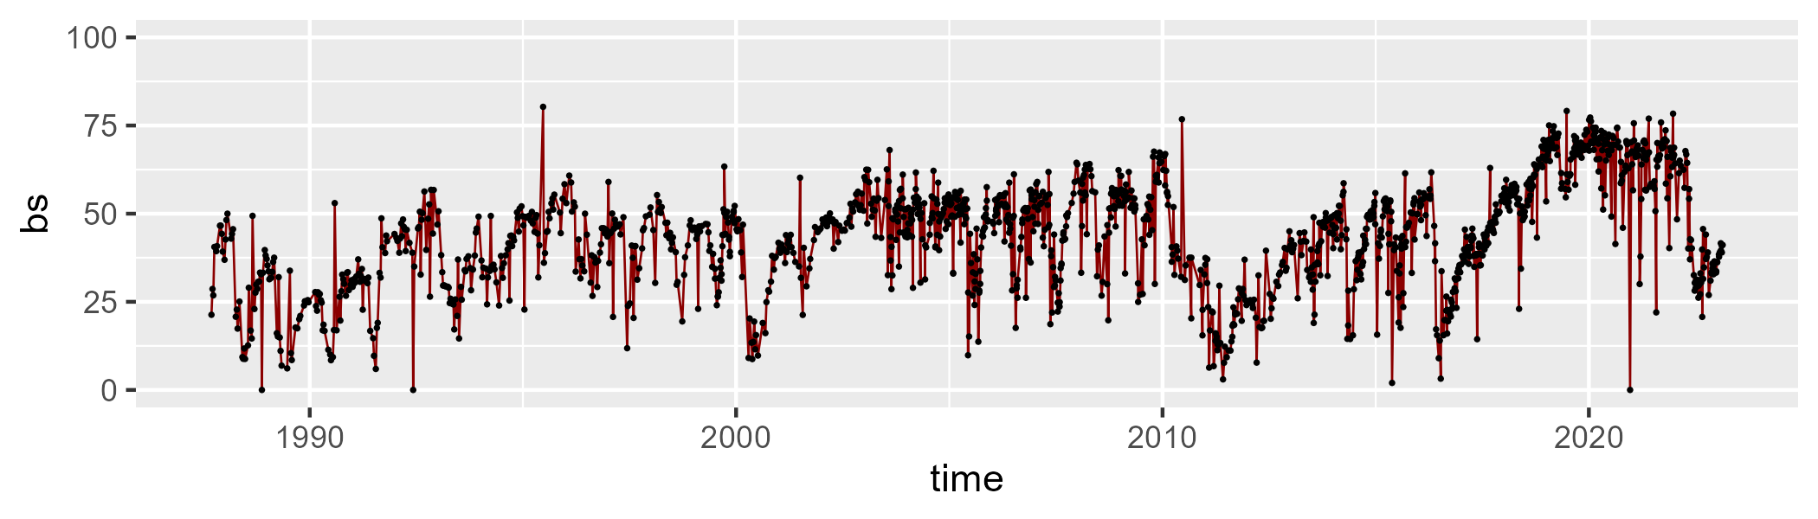

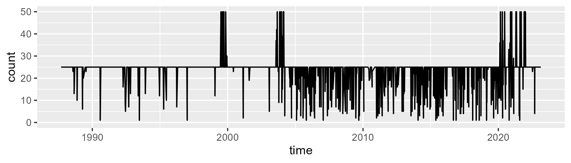

Min. : 1.00 1st Qu.:25.00 Median :25.00 Mean :23.29 3rd Qu.:25.00 Max. :50.00

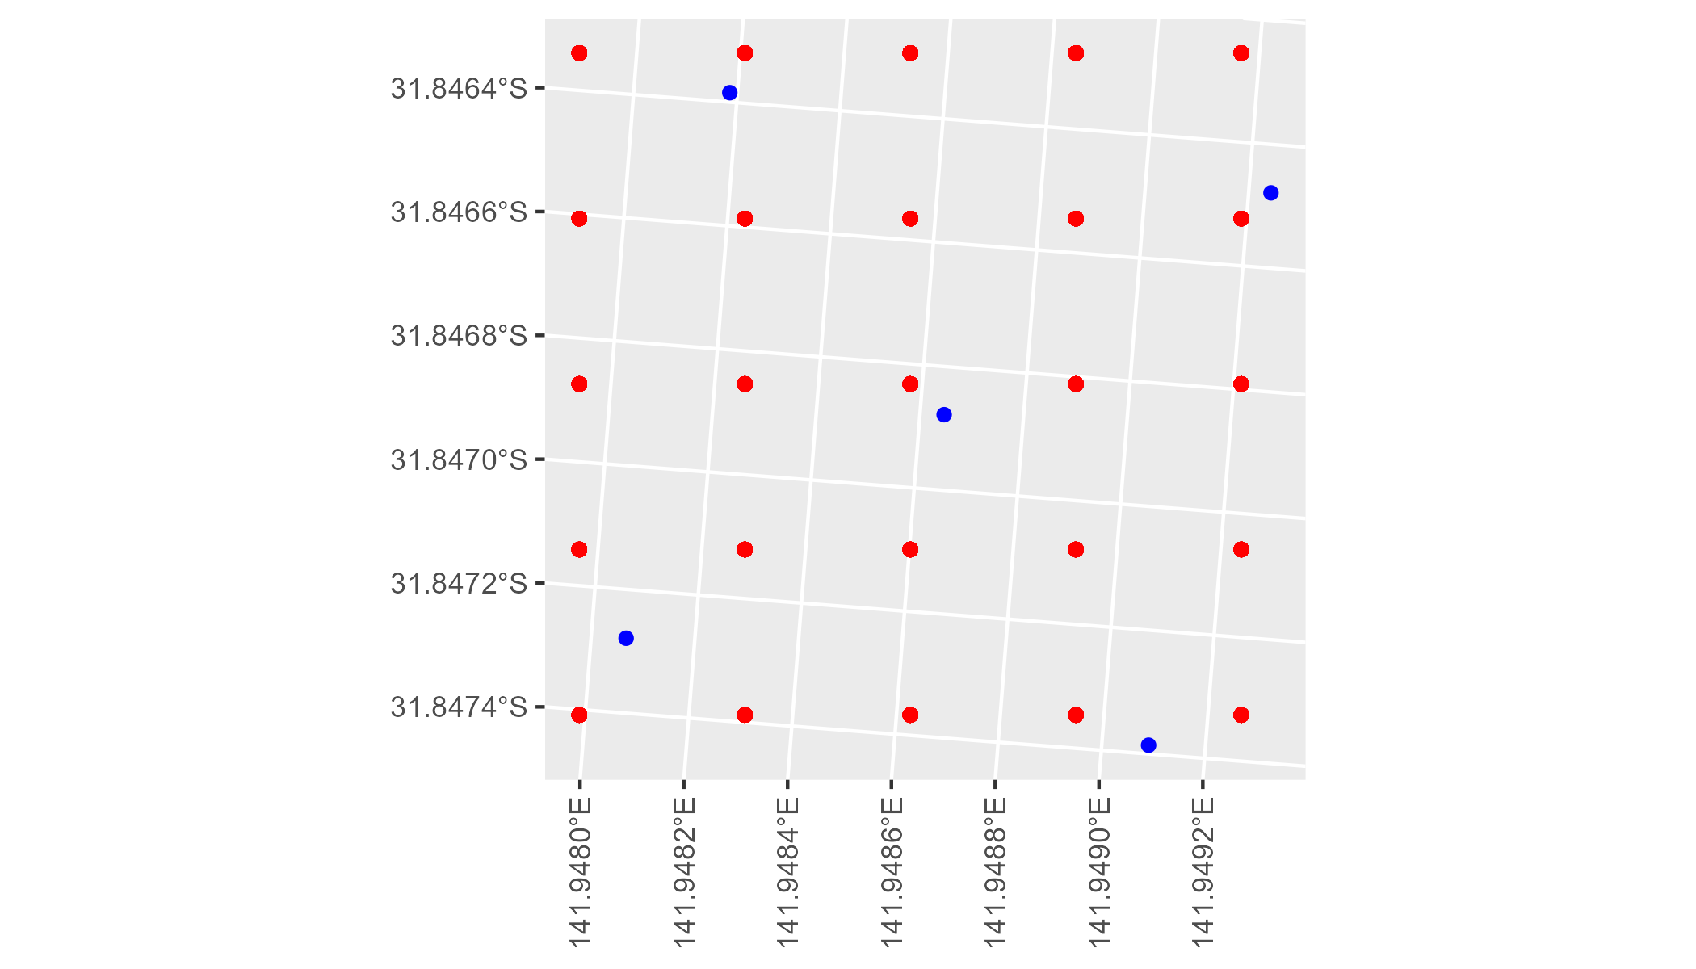

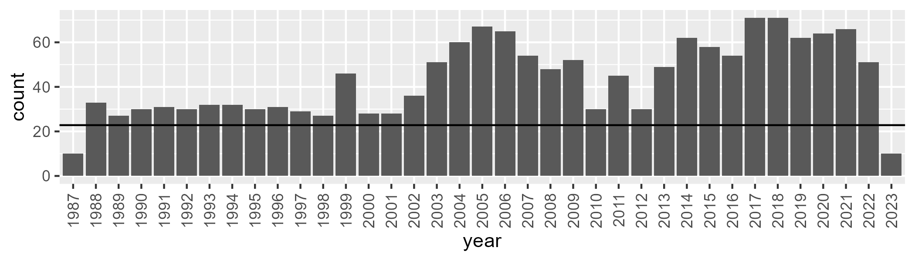

Number of samples: 1600